**Application**

**DETAILED PROJECT REPORT**

**for**

**CONSTRUCTION OF PHYSICAL INFRASTRUCTURE FOR SHRI VAISHNAV VIDYAPEETH VISHWAVIDYALAYA AT GRAM BAROLI, SANWER ROAD, INDORE**

Name of the Firm…………………………………………………………………..

Address……………………………………………………………………………..

Phone, Mobile, Fax No…………………………………………………………..

Last Date & Time for Submission: October 20, 2015, 05:30 PM

**Shri Vaishnav Vidyapeeth Vishwavidyalaya**

**Eligibility**

1. The Consultancy firms should have at least 10 years of experience (As on October 20, 2015).
2. The firm must have executed at least one project of the value of Rs.10.00 crores for an educational institution of national repute and other prestigious departments/institutions.
3. No Joint Venture or substitute shall be allowed.
4. The firm should be having at least two senior graduate architects out of which one should be having an experience of at least ten years and other architect should be having an experience of 7 years or more. These architects should be working with the firm for the last three years. The firm should be member of the Council of Architecture and Indian Institute of Architects.
5. The firm should have a minimum Average Annual Turnover of Rs. 4 crores from consultancy works in previous three years. Audited balance sheet and other supporting documents to be submitted along with the application.
6. The applicant should be having office in Indore with qualified manpower, or should confirm in writing that it is willing to set up such an office in Indore, if the work is awarded to the firm.

**Selection Procedure**

The firms interested in participation in the selection process should submit documents as per Annexure-1 to establish the fact that they meet above eligibility criteria. Firms not fulfilling the above criteria are likely to be disqualified.

1. The shortlisted applicants will be invited to make a presentation of their proposals.
2. The Panel of Evaluators appointed by the University shall recommend one of the firms for the award of work based on merit of the proposal.

**Annexure -1**

**Information Sheet**

Please provide the requested information against each of the items. Prepare a document where information for every item is included in the given order of items. Information provided must be detailed and complete. if adequate information is not provided, the application will not be considered.

|  |  |  |
| --- | --- | --- |
| 1 | Details of Master planning work of integrated townships/ campus works completed or in hand in the last Five years ( besides giving summary, details of each project are to be separately enclosed; client certificate to be enclosed wherever applicable, otherwise experience will not be considered. | Client Name, Work Title, Period (From - To), Value  Annexure- 1 (A) |
| 2 | Details of buildings/ complexes completed or in progress in the education sector in the last five years (besides giving summary, details of each project are to be separately enclosed; completion certificate to be enclosed wherever applicable, otherwise experience will not be considered.) | Client Name, Work Title, Period ( from - To), Value  Annexure- 1 (B) |
| 3 | Experience/ Performance Certificate and Testimonials from clients. | Annexure- 1 (C) |
| 4 | Annual Turnover in last 5 years (enclose documentary evidence, such as annual accounts, etc. in terms of consultancy fee). | Annexure- 1 (D) |
| 5 | In-house Infrastructure: Software, Other Computer Facilities (number of PCs, Peripherals etc.) | Annexure- 1 (E) |
| 6 | Details of the Firm   1. Year of Incorporation 2. Location of Offices 3. Area of office space in each of the offices 4. Number of architects, engineers, support staff in each of the offices 5. Support firms (with brief details of each) engaged in the recent past for items, such as Structural design, Air-conditioning design, water supply, electrical infrastructure , interior, etc. | Annexure- 1 (F) |
| 7 | Details of principal architect, other architects, structural engineers, civil engineers and electrical engineers working in the firm (separate biodata of each staff member to be attached). | Annexure- 1 (G) |
| 8 | Name of the Firm with Address and Registration Number. |  |
| 9 | Any other details | Annexure- 1 (H) |

**List of the Documents to be Submitted alongwith the Application**

The following documents should be enclosed along with the application:

1. Completed Information Sheet (Annexure-1)
2. Attested photocopy of Registration Certificate from national professional bodies of Principal Architect and other Architects.
3. Details of works carried out as mentioned in the information sheet.
4. Self attested Bio-data of Architects and Engineers on the roll of the Firm.
5. Audited Balance Sheet highlighting the consultancy fees for the last three years.
6. Copies of PAN/TAN card & Service Tax Registration
7. Signature of authorized signatory with official seal on each page
8. Registration with Provident fund Organization.

**Note:**

1. All certificates should be attested by the Firm’s authorized signatory.
2. University’s representative may visit the office of the Firms and inspect the completed major projects done by the Firms.
3. Please attach details of associate consultants ( Annexure-1 (I)
4. Architectural Firm should be aware of CPWD procedures and should give name of the person in the Firm who is aware of CPWD rules.
5. Cut off date in all cases is 20th October, 2015.

**ANNEXURE 2**

**PRICE BID PROFORMA**

**PRICE BID FOR SELECTION OF ARCHITECTURAL FIRM**

The particulars of fees quoted for providing professional services for designing of the campus for Shri Vaishnav Vidyapeeth Vishwavidyalaya at Indore are as under:

**NAME OF THE FIRM………………………………………………………….**

**ANNEXURE-3**

**COMPREHENSIVE FEES FOR ALL ITEMS**

FINANCIAL OFFER

Location:

Date:

To,

The Vice Chancellor,

Shri Vaishnav Vidyapeeth Vishwavidyalaya - Indore

Subject: - Construction of Shri Vaishnav Vidyapeeth Vishwavidyalaya Campus for Shri Vaishnav Vidyapeeth Trust at Gram Baroli, Sanwer Road, Indore.

|  |  |  |
| --- | --- | --- |
| **S.No.** | **Nature of Work in Brief** | **Fee** |
| 1 | Architectural and Landscaping, Structural drawing with details and electrical, LAN, Services and utility & allied services etc. and Construction Project Management. | (Please quote percentage for designing and construction project management. |

Authorised Signatory ( In full with initials) :

Name of the Firm :

Address :

**Please Note :**

1. The above fee includes the charges for interior design and layout for a typical room to accommodate the suggested furniture and accessories.
2. The above fee quoted is exclusive of service tax ( i.e., Service Tax will be paid by the Trust in addition to the fees quoted) but inclusive of income tax and all other taxes as applicable.
3. The above fee quoted is also inclusive of site visit charges, provision of architect’s representative at site for periodic (twice a week) supervision of work and all services as stated under the heading “ Services to be provided by the Architect”

Place :

Date: Signature with Seal of the Firm

**ANNEXURE – 4**

**SERVICES TO BE EXTENDED BY THE ARCHITECTURAL FIRM**

The firm is required to provide services in respect of the following:

**Part 1 – Architecture**

1. Taking Client’s directives for the preparation of design brief.
2. Overall design and site development.
3. Structural design.
4. Design of sanitary, plumbing, drainage, water supply, sewerage system.
5. Design of electrical, electronic, communication systems.
6. Air- conditioning design (HVDC)
7. Elevators.
8. Fire detection, Fire protection and security systems.
9. Periodic inspection and evaluation of construction works.

**Part II – Allied Fields**

1. Landscape Architecture (Architect will have to make provision for landscaping in the area of land given to him).
2. Interior layout for a room and common/interaction arms/rooms.
3. Signage for the campus that Firm is designing.

**Schedule of Services**

The Architectural Firm shall, after taking instructions from the Client, render the following services:

**Concept Design [Stage 1]**

1. Interact with the client to understand the requirements of each academic and non-academic department and freeze the requirements after examining site constraints and potential; and prepare a design brief for client’s approval.
2. Prepare drawings and documents to enable the client to get done the detailed survey and soil investigation at the site of the project.
3. Prepare conceptual designs with reference to requirements given and prepare rough estimate of the cost on area basis.

**Preliminary Design and Drawings [Stage 2]**

Modify the conceptual design incorporating required changes and prepare the preliminary drawings, sketches, study model etc. for the Client’s approval along with preliminary estimate of cost on area basis.

**Drawings for Client’s/ Statutory Approvals [Stage 3]**

Prepare drawings necessary for statutory approvals and ensure compliance with codes, standards and legislation, as applicable, and assist the Client in obtaining the statutory approvals. (It will be responsibility of the architectural firm to get all necessary permissions for construction and building use. No separate amount will be paid for this. However, all fees deposited in the statutory bodies will be borne by the Trust.

**Working Drawing and Tender Documents [Stage 4]**

Prepare working drawings, specifications and schedule of quantities sufficient to prepare estimate of the cost and tender documents including code of practice covering aspects like mode of measurement, method of payments, quality control procedures on materials & works and other conditions of contract. The schedule of quantities should be prepared from the execution drawings and should be sufficiently correct. ( Variation should not be more than 5% except for earth work and foundation where maximum of 10% of variation can take place. In case of greater variation in quantities architectural firm will have to inform the client in writing giving the reasons thereof and submitting a fresh Bill.

**Appointment of Contractors [Stage 5]**

Prepare in consultation with the Madhya Pradesh State Govt. agency construction invite, receive and analyze tenders; advice client on appointment of contractors under the two bid system. A pre-qualification meeting will be called to clear the queries of the bidders before submission of the tenders. Firm’s representative will also have to be present in this meeting.

**Construction [Stage 6]**

1. Prepare and issue working drawings and details for proper execution of the works during construction well in time.

2. Approve samples of various elements and components.

3. Check and approve shop drawings submitted by the contactor/ vendors.

4. Visit the site of work, at intervals mutually agreed upon (minimum two times a week), to inspect and evaluate the construction works and where necessary clarify any decision, after interpretation of the drawings/specifications, attend conferences and meetings to ensure that the project proceeds generally in accordance with the conditions of contract and keep the Client informed and render advice on actions, if required.

5. In order to ensure that the work at site proceeds in accordance with the contract documents/drawings and to exercise time and quality controls, the day to day supervision will be carried out by a Project team (Clerk of works/ Site Supervisors etc) under the general guidance of the architectural firm.

6. Issue of interim certificates by the architectural firm.

7. Settlement of extra/ non-tender items by the architectural firm.

8. Issue Virtual Completion Certificate of works completed, and prepare snag list.

**Completion [Stage 7]**

1. Prepare and submit completion reports and drawings for the project as required and obtain “Completion / Occupancy Certificate “from statutory authorities, wherever required

(Building use permission).

2. Issue three sets of as built drawings including that of services and structures (hard copy and soft copy both).

**Miscellaneous**

1. Architectural firm will be liable for the damages arising out of its own fault.

2. No extra payment will be made to the architectural firm and its consultants for travelling to and fro from Indore. It will be desirable that the firm has an office or a representative in Indore.

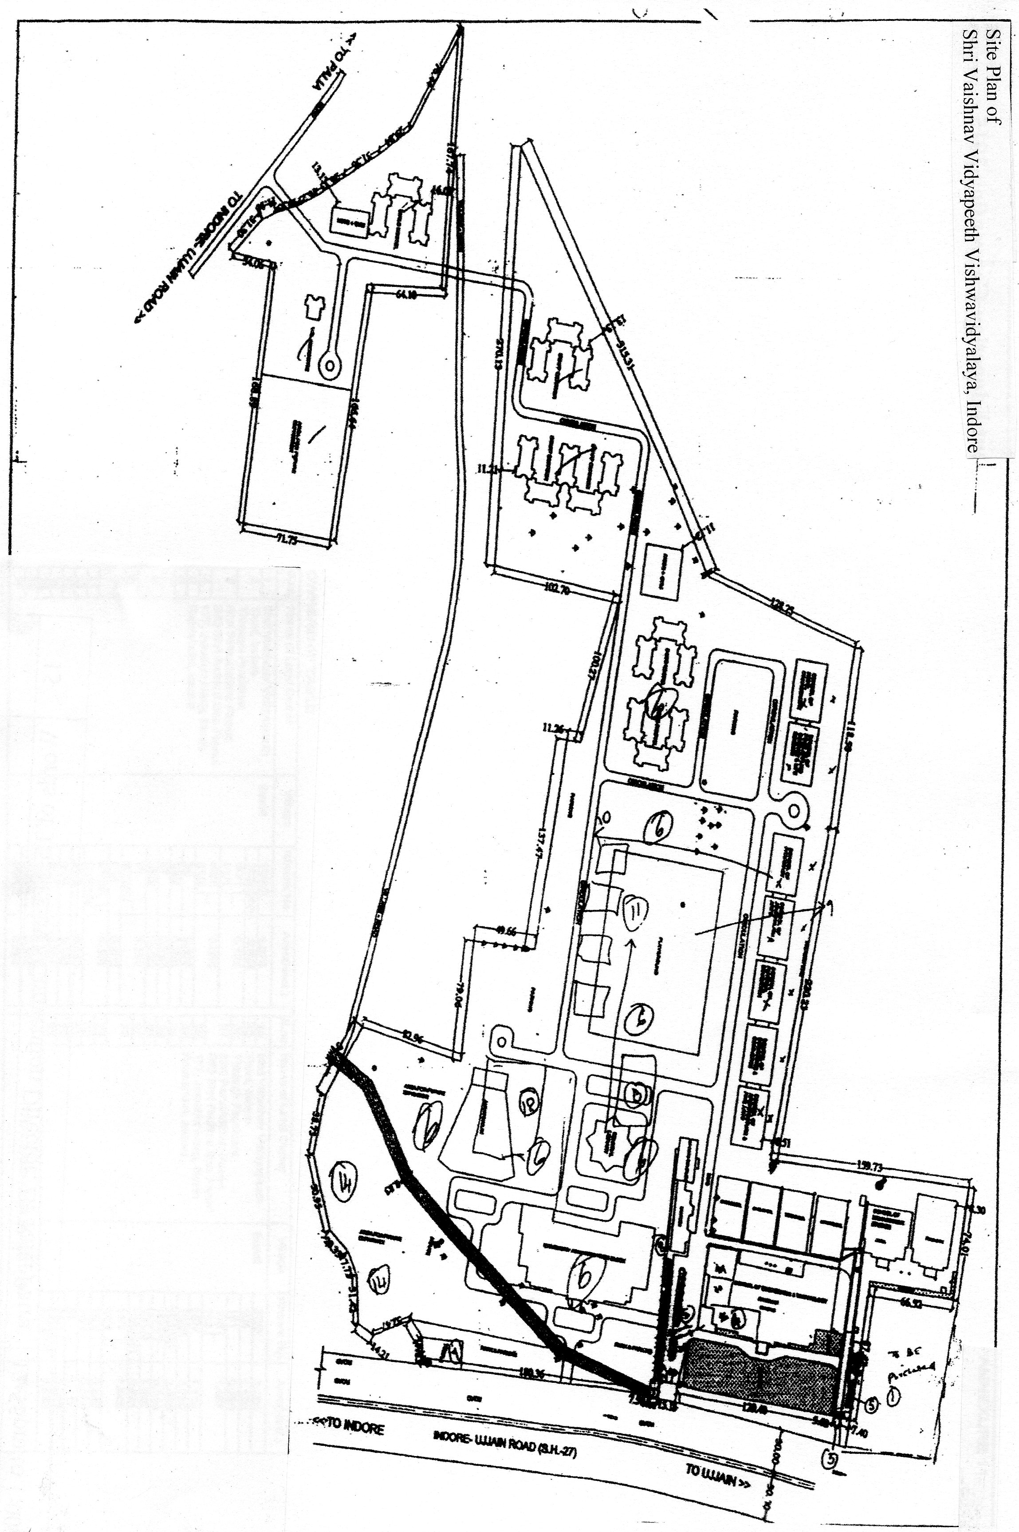

**Area : 51 Acres**