**Dainik Bhaskar – 19 April 2015:**

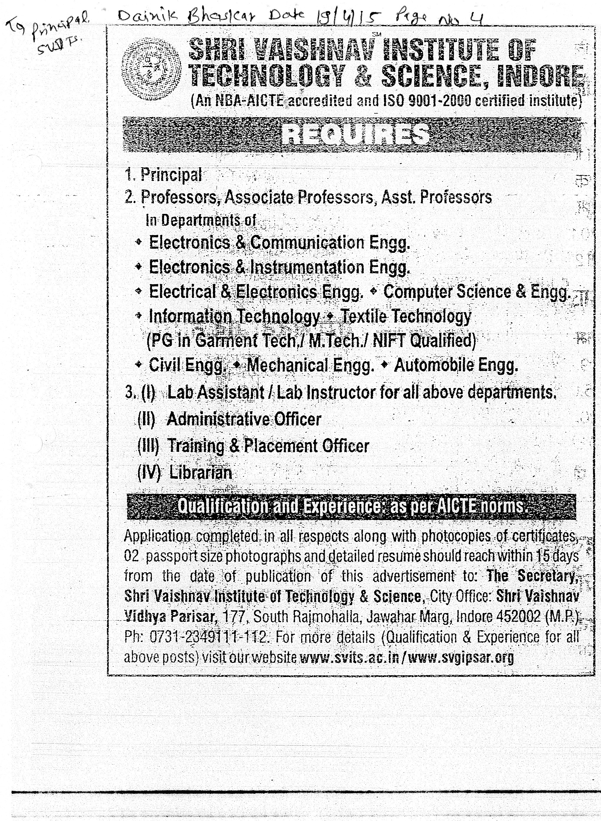

**Times of India – 09 December 2015:**

