Audited Financial Statement for 2012-13

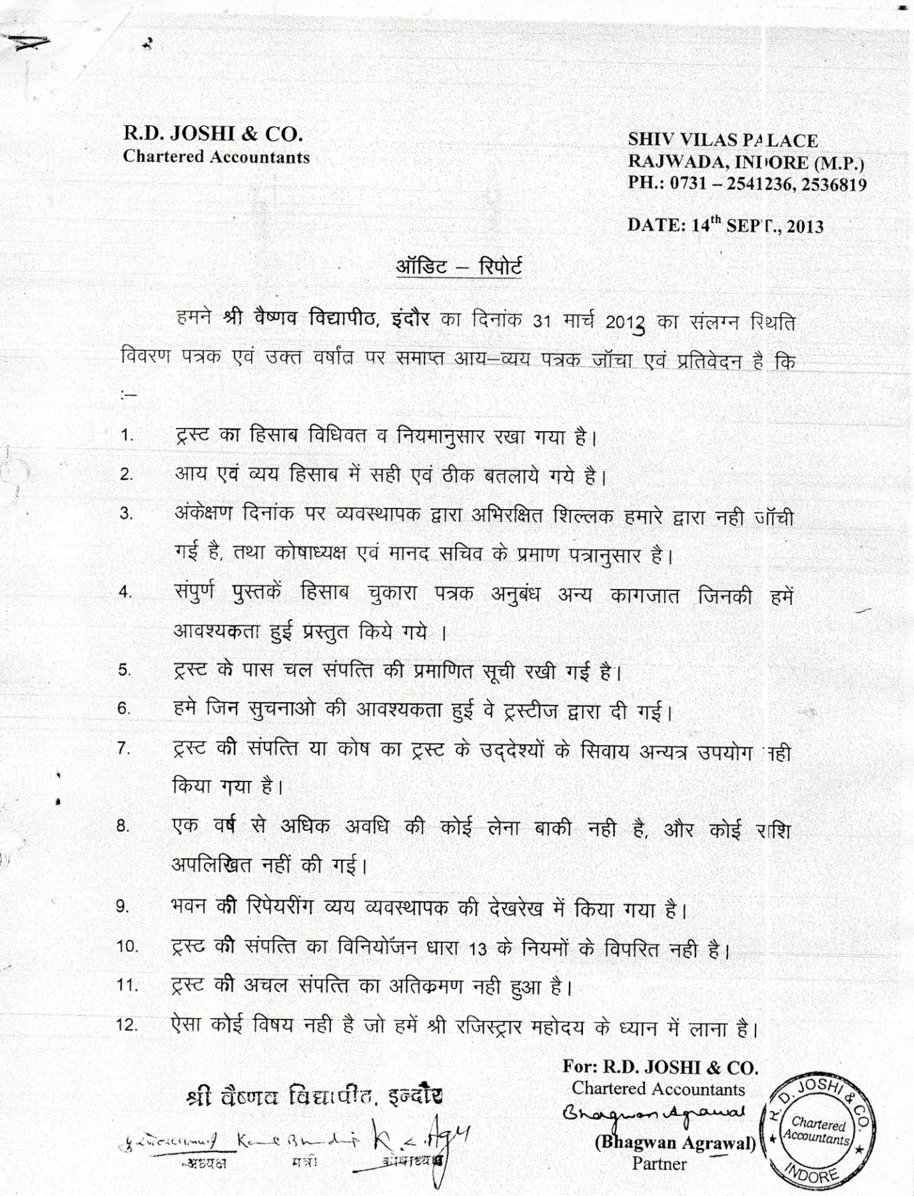

Audited Income & Expenditure Statement for the year 2012-13
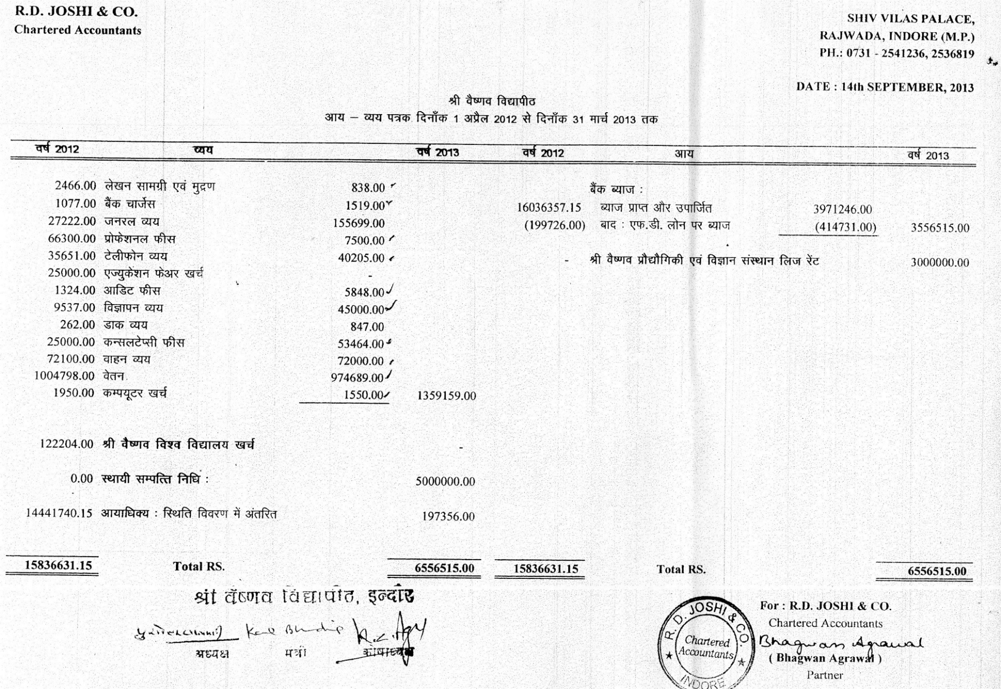

Audited Balance Sheet as on 31 March 2013

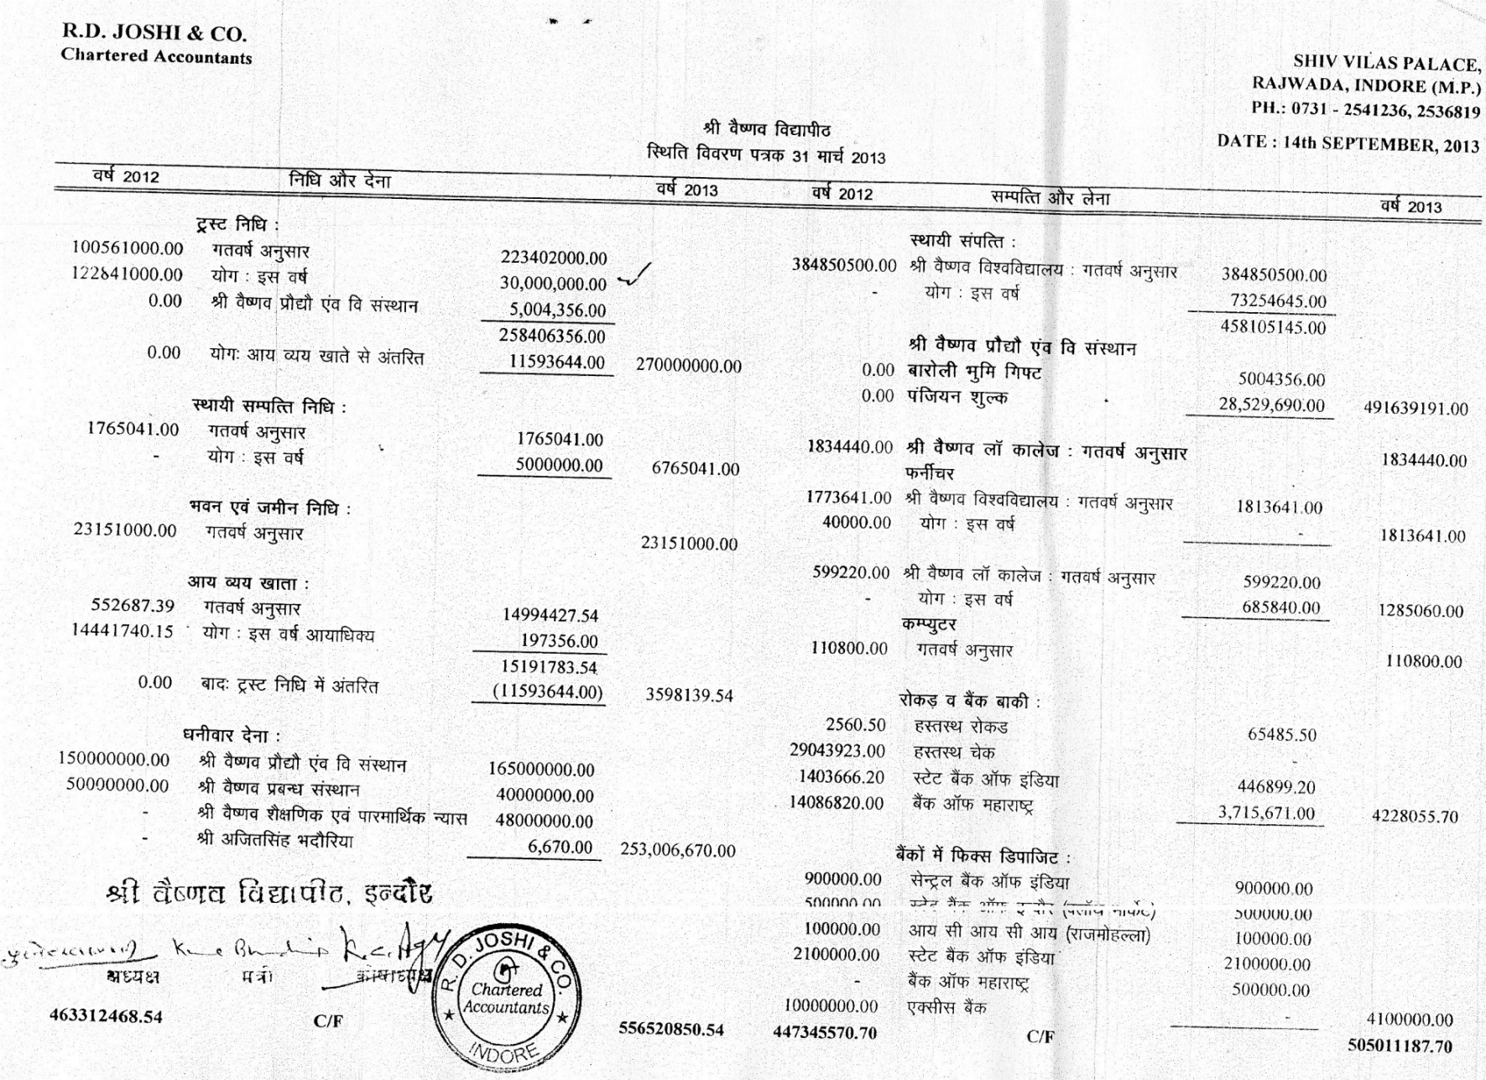

Audited Balance Sheet as on 31 March 2013 (continued)

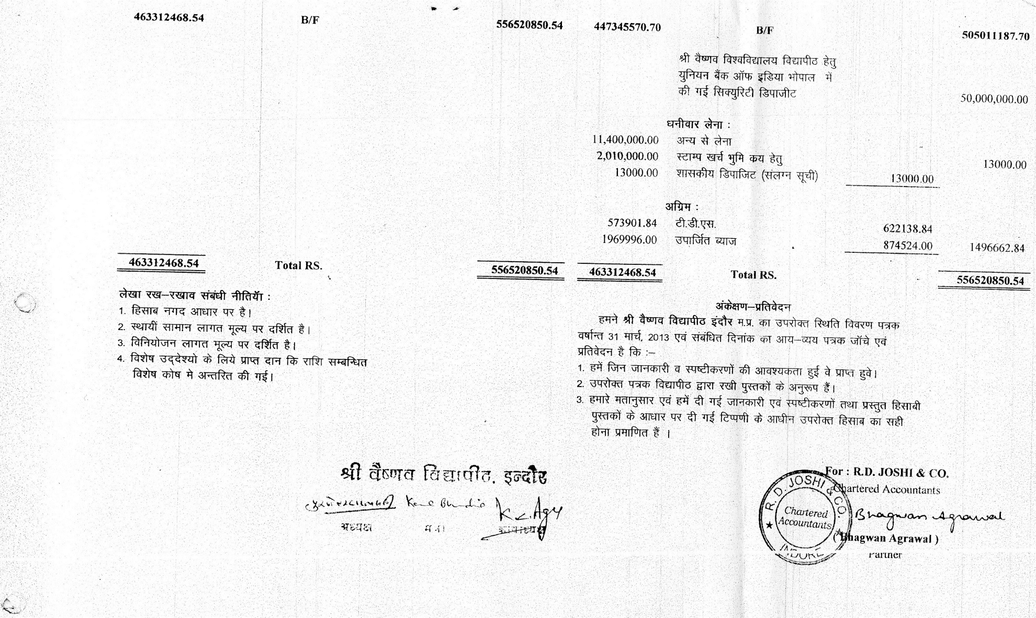

Audited Financial Statement for 2013-14

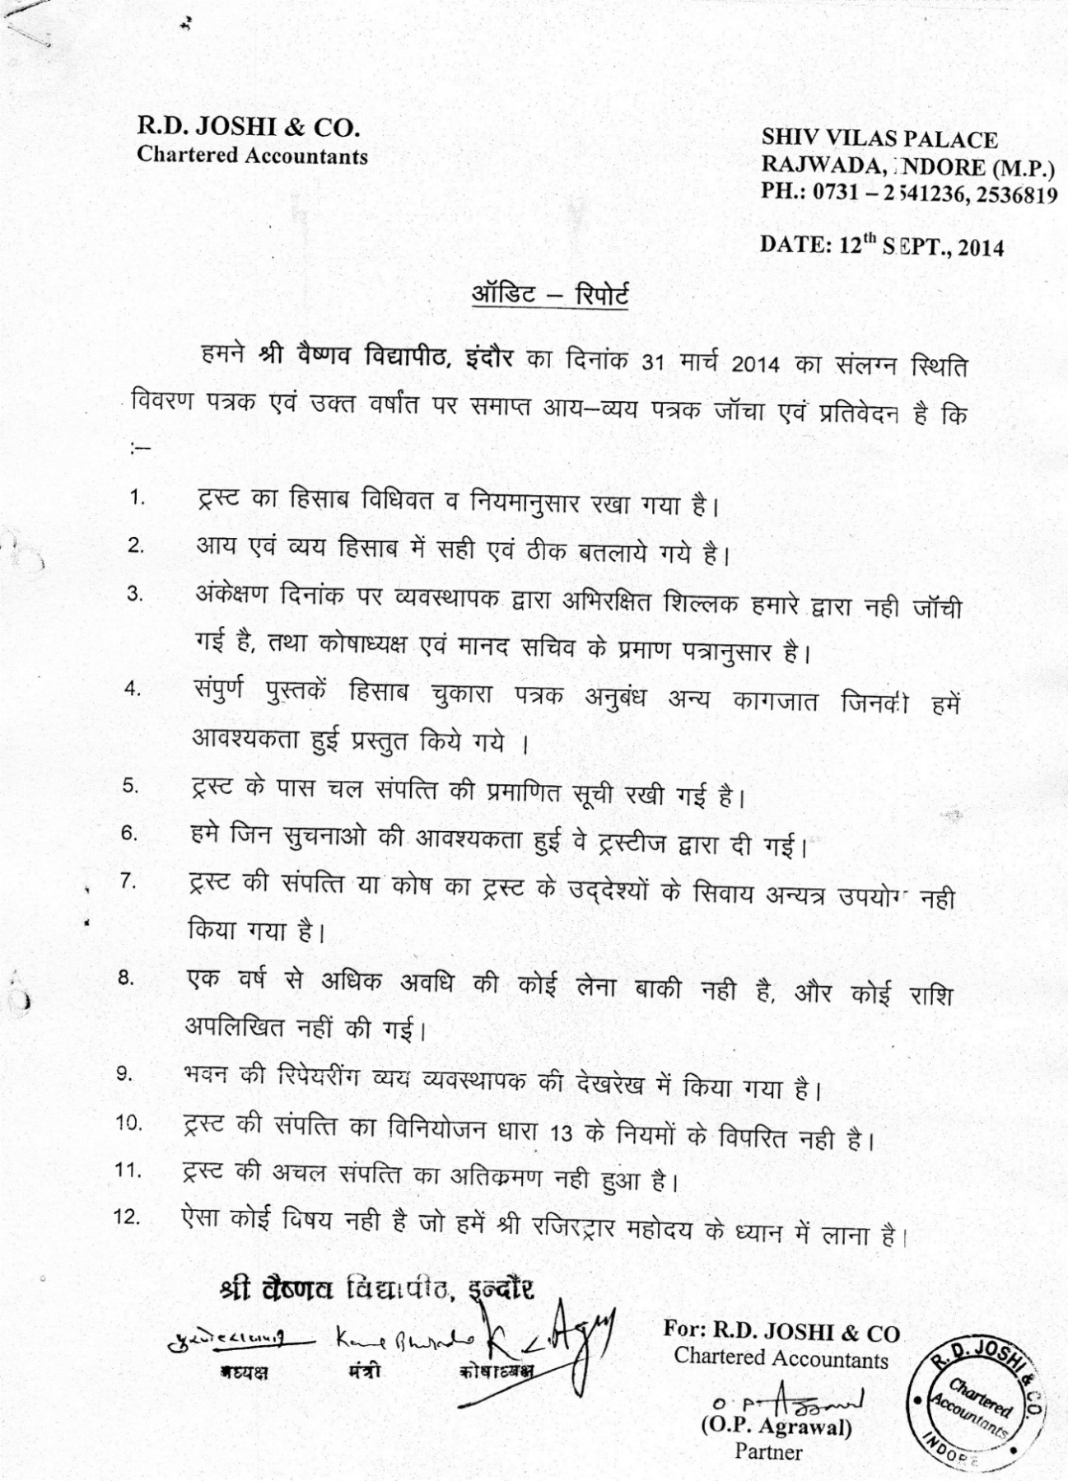

Audited Income & Expenditure Statement for the year 2013-14

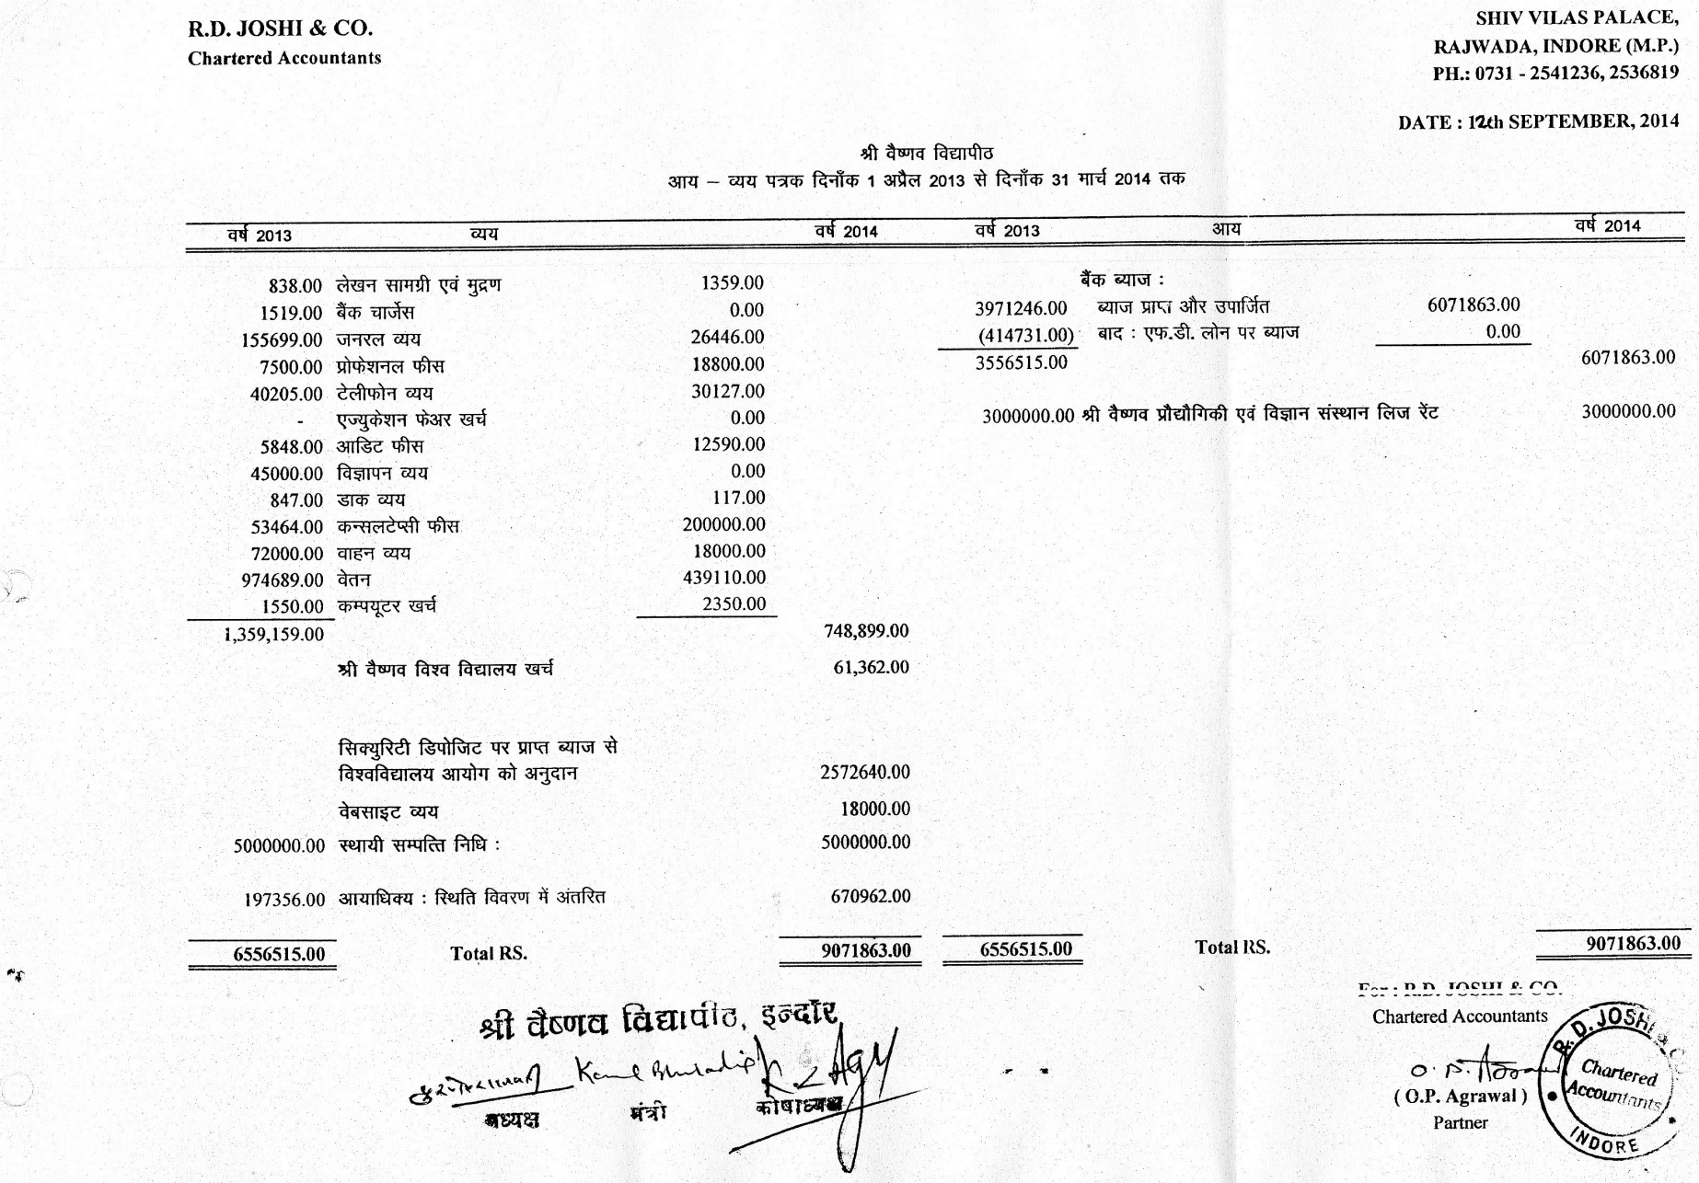

Audited Balance Sheet as on 31 March 2014

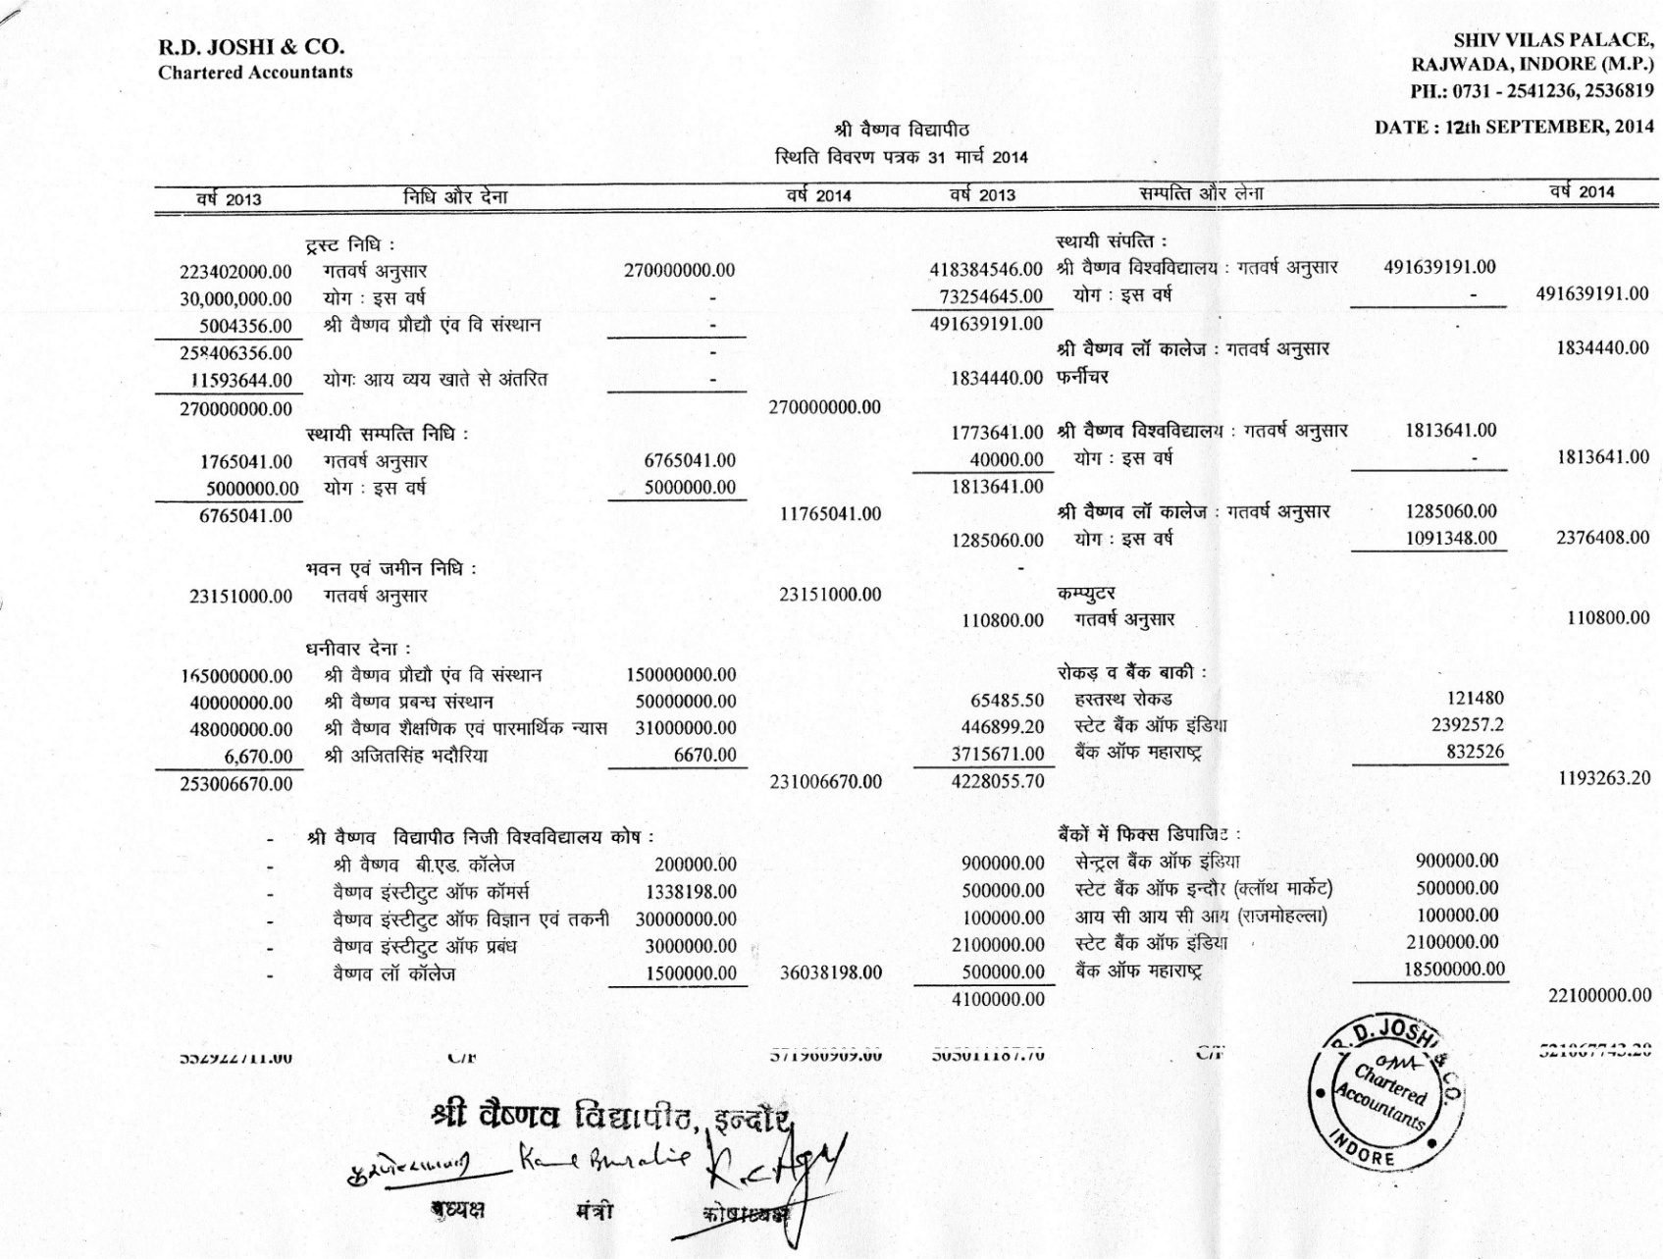

Audited Balance Sheet as on 31 March 2014 (continued)

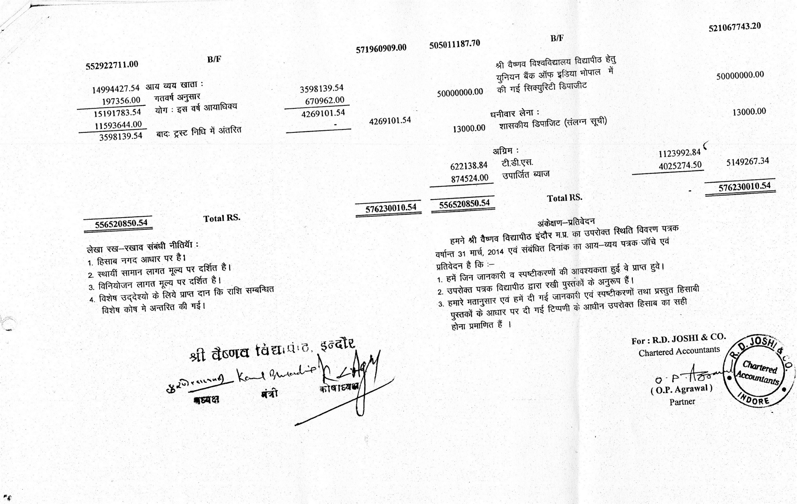

Audited Schedules to Balance Sheet for 2013-14

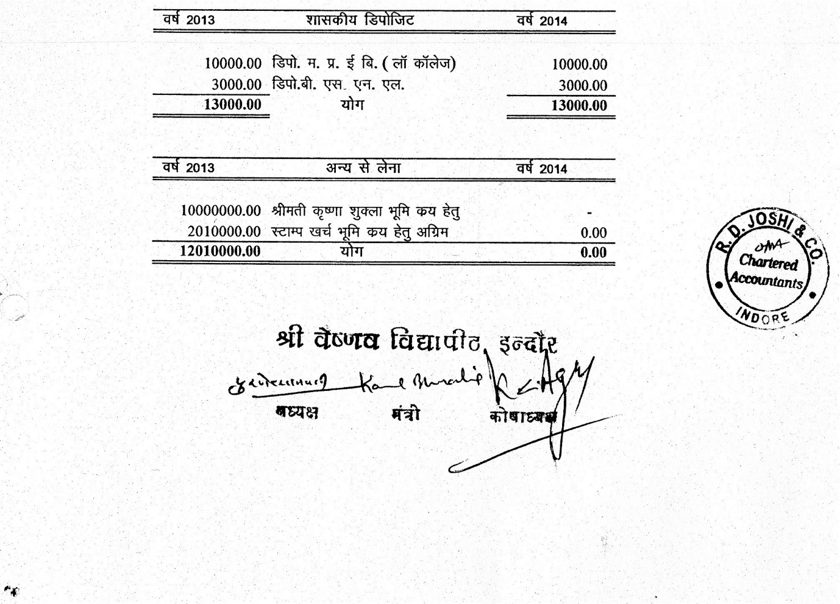

Audited Financial Statement for 2014-15

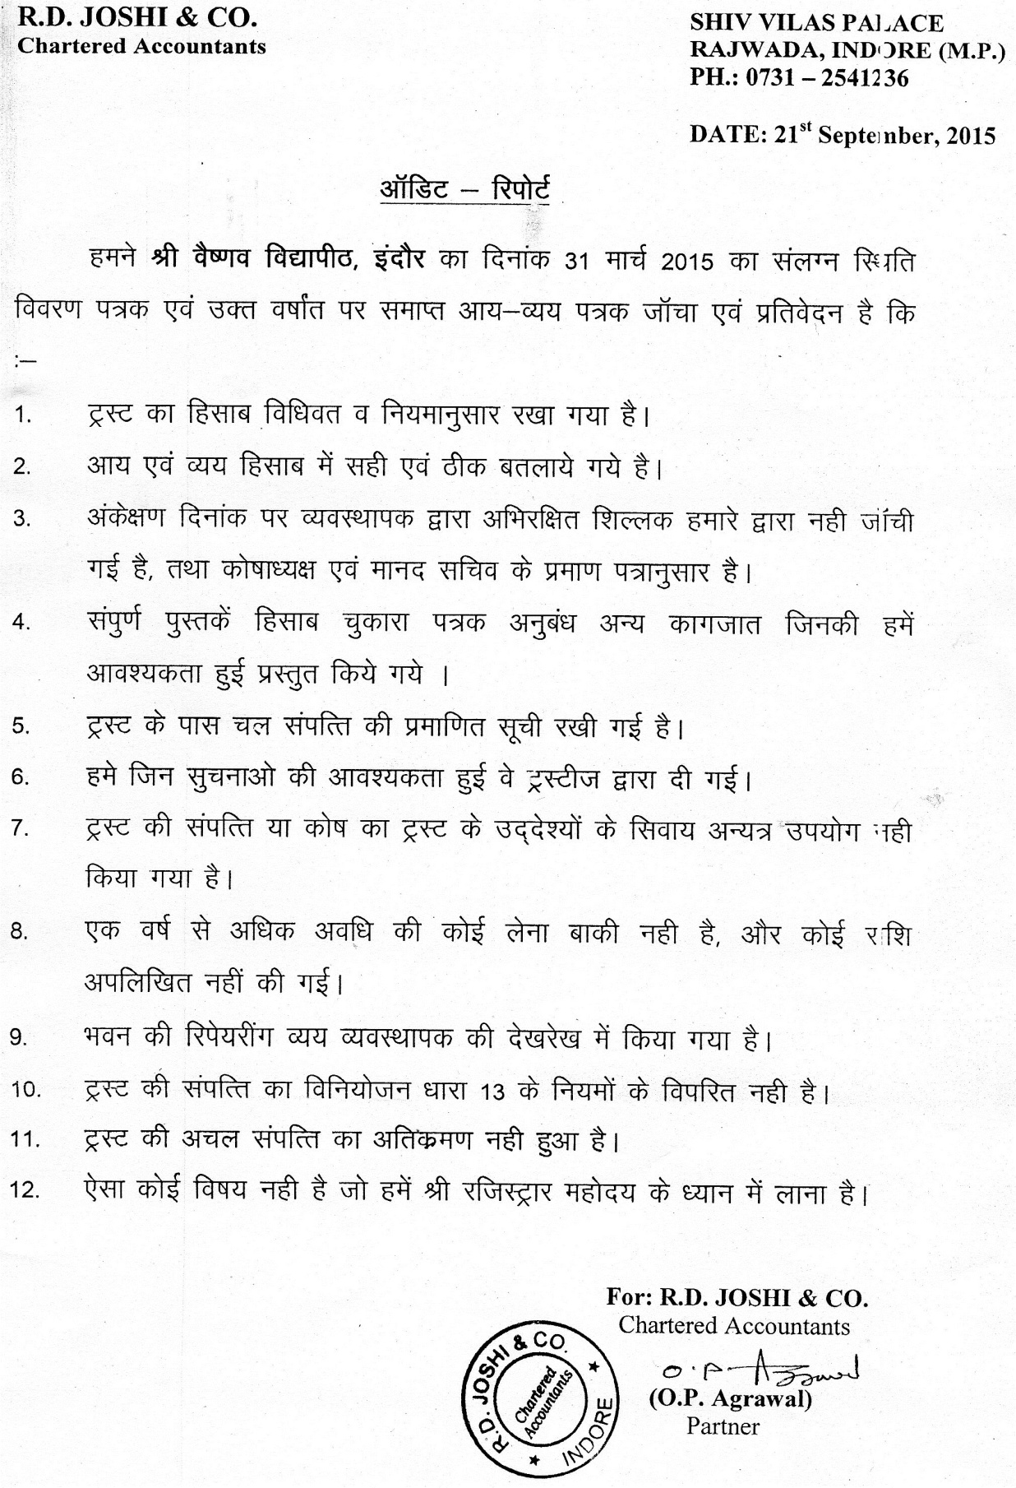

Audited Income & Expenditure Statement for the year 2014-15

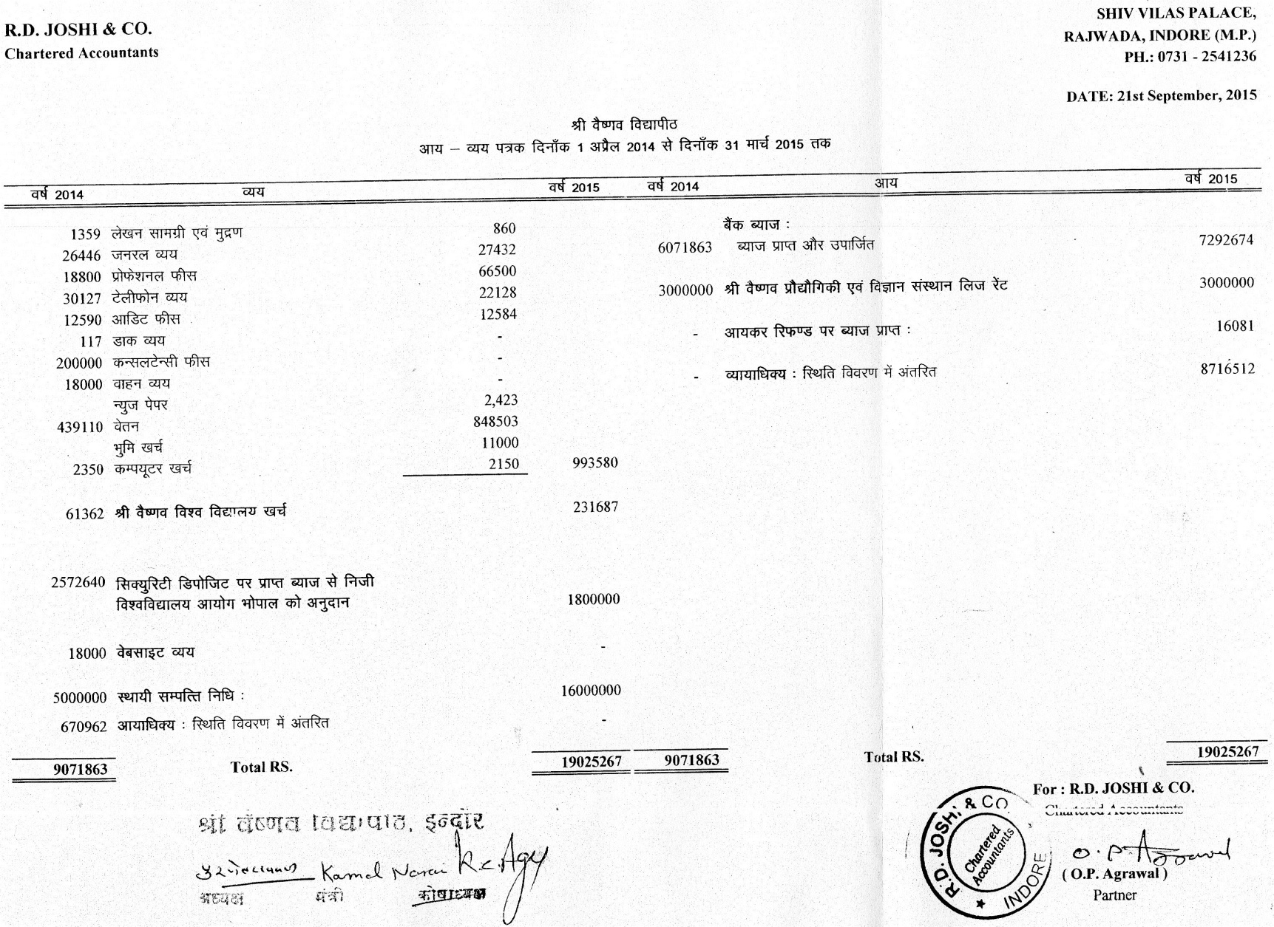

Audited Balance Sheet as on 31 March 2015

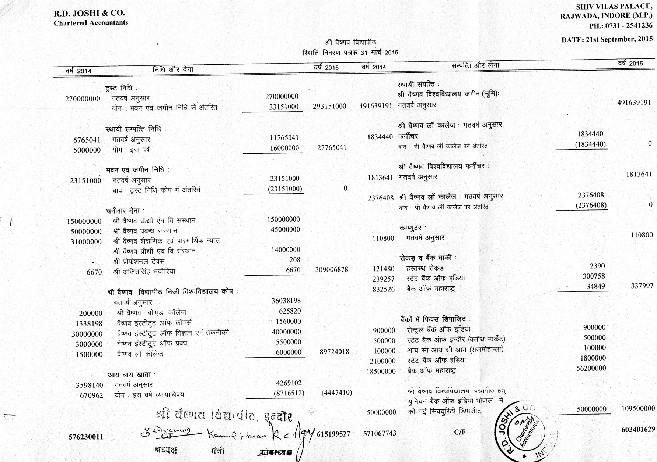

Audited Balance Sheet as on 31 March 2015 (continued)

