**Audited Income & Expenditure Statement for the year 2012-13**

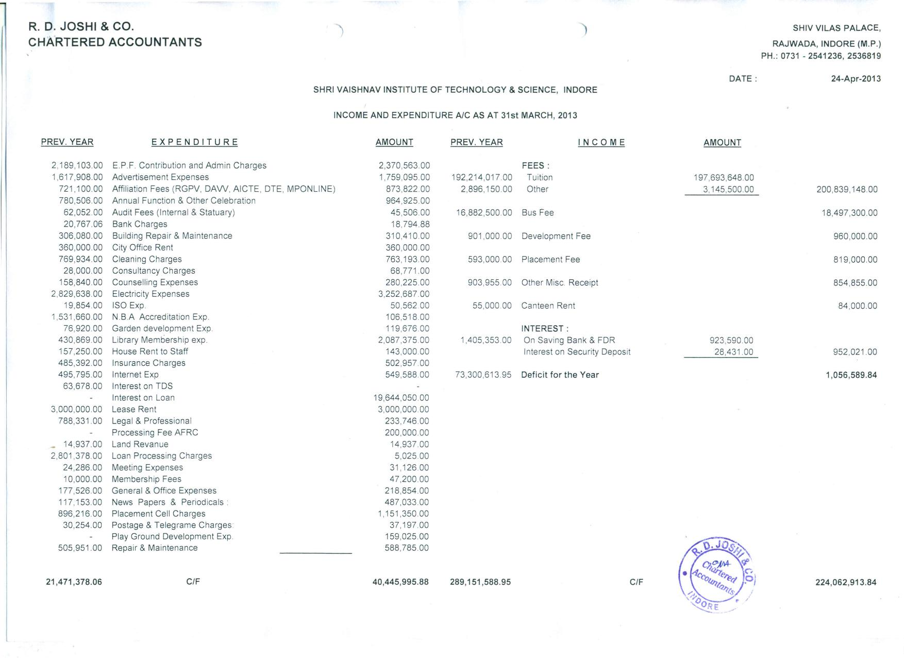

**Audited Income & Expenditure Statement for the year 2012-13 (continued)**

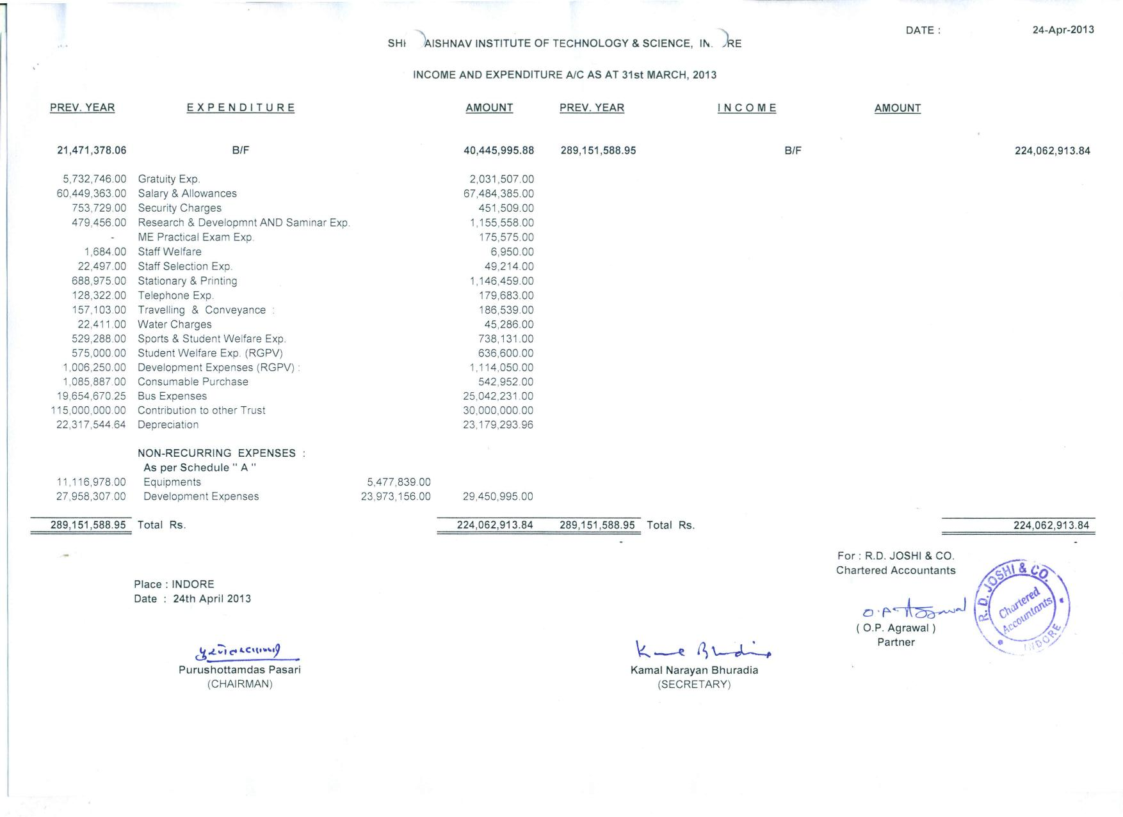

**Audited Balance Sheet as on 31 March 2013**

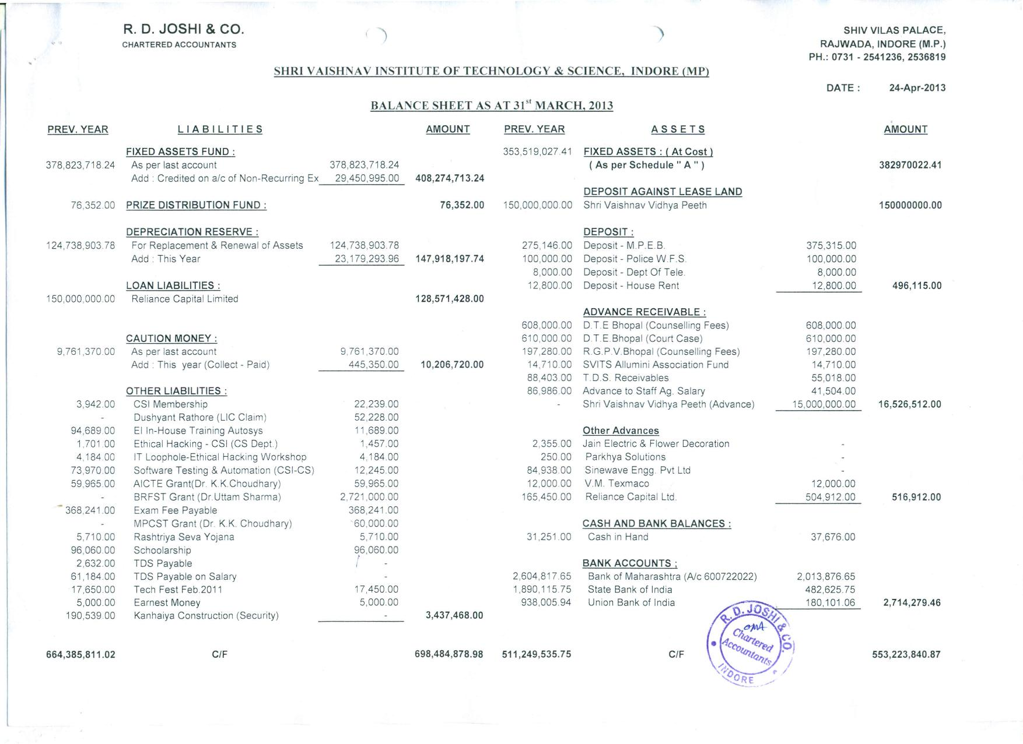

**Audited Balance Sheet as on 31 March 2013 (continued)**

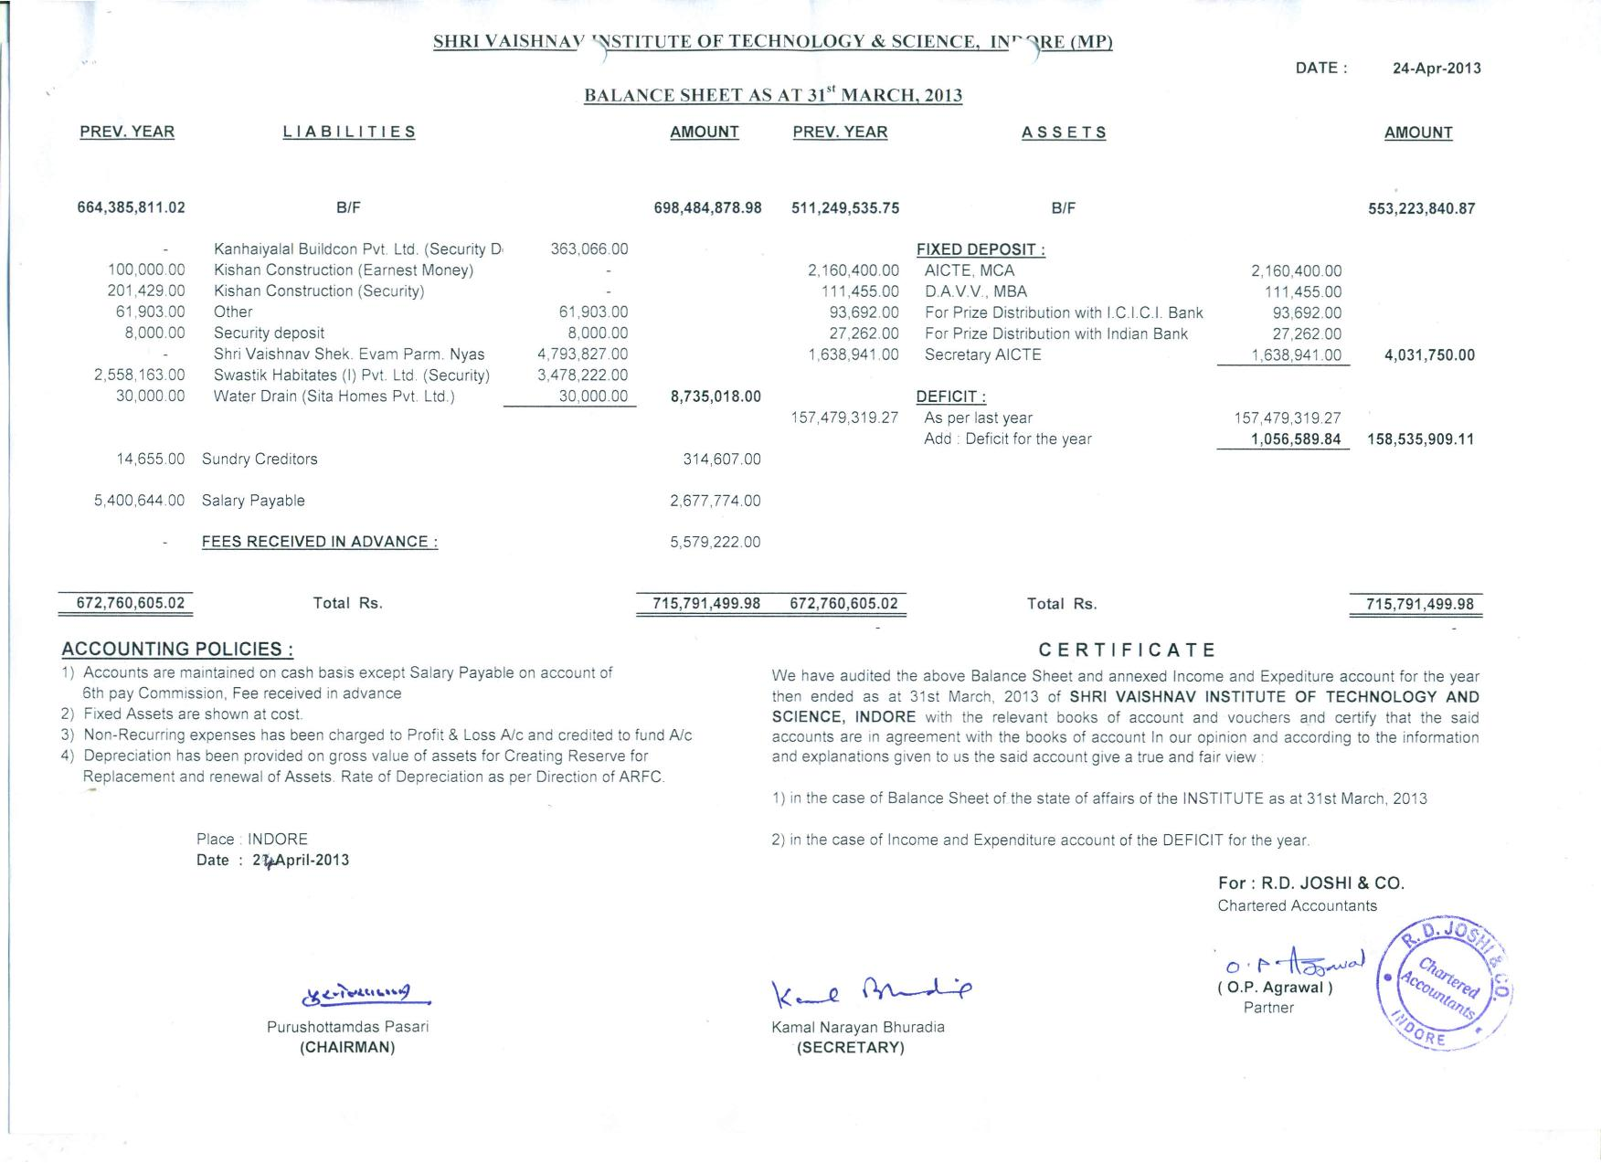

**Schedules to Audited Balance Sheet as on 31 March 2013**

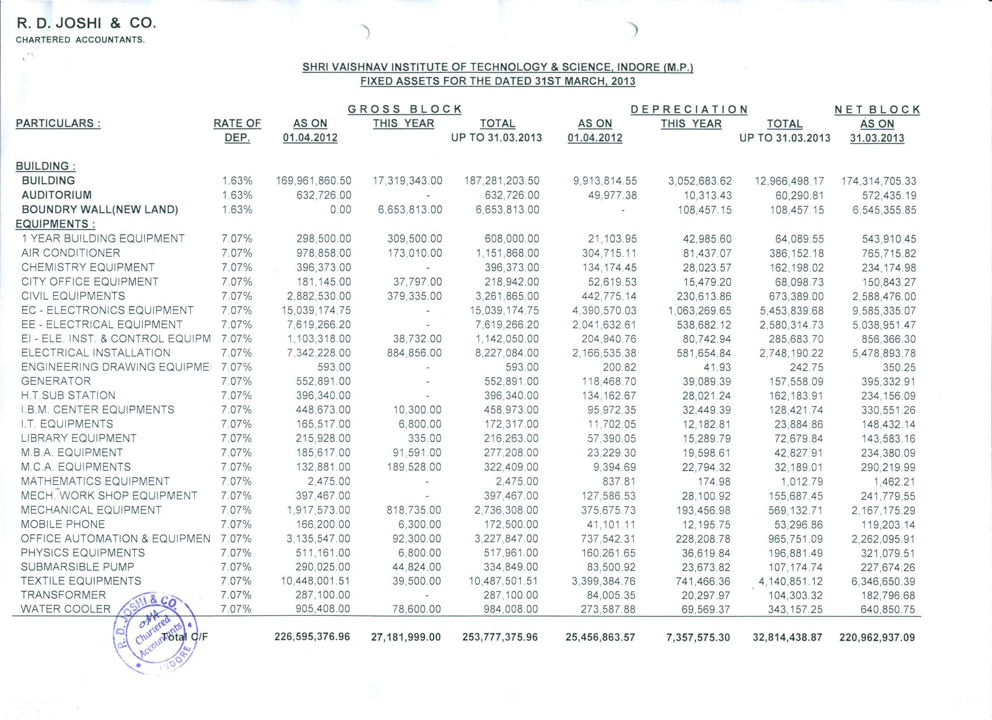

**Schedules to Audited Balance Sheet as on 31 March 2013 (continued)**

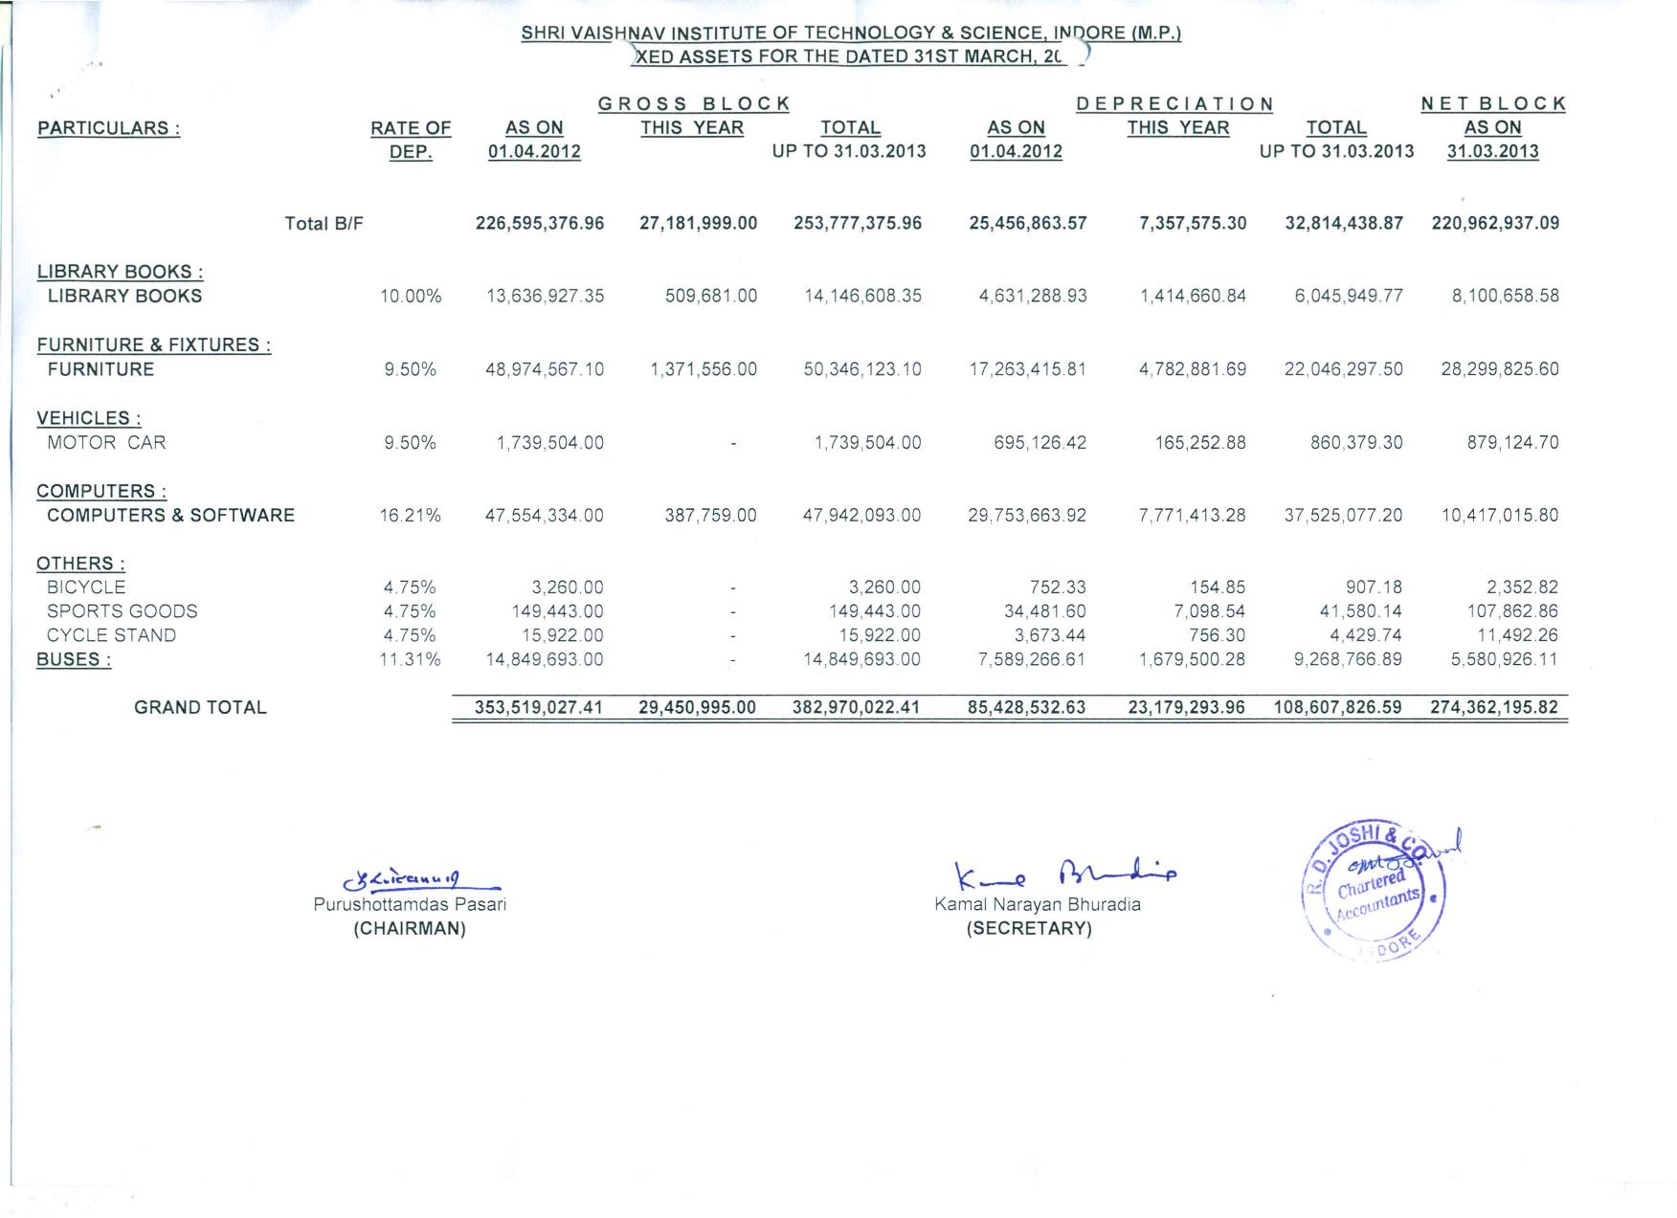

**Audited Income & Expenditure Statement for the year 2013-14**

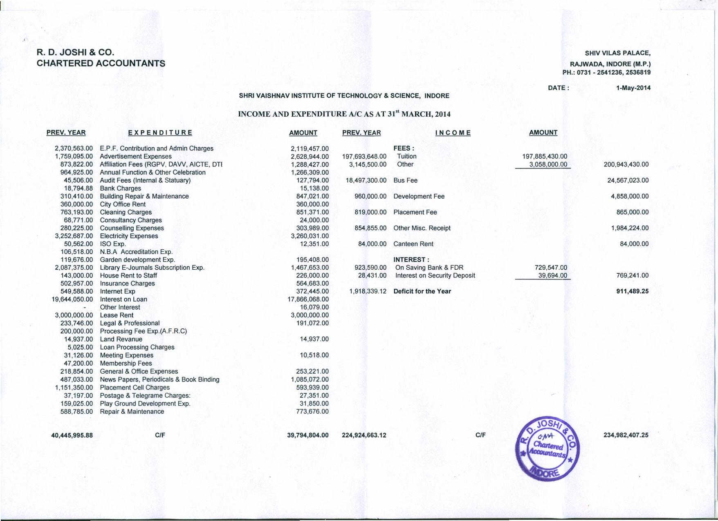

**Audited Income & Expenditure Statement for the year 2013-14 (continued)**

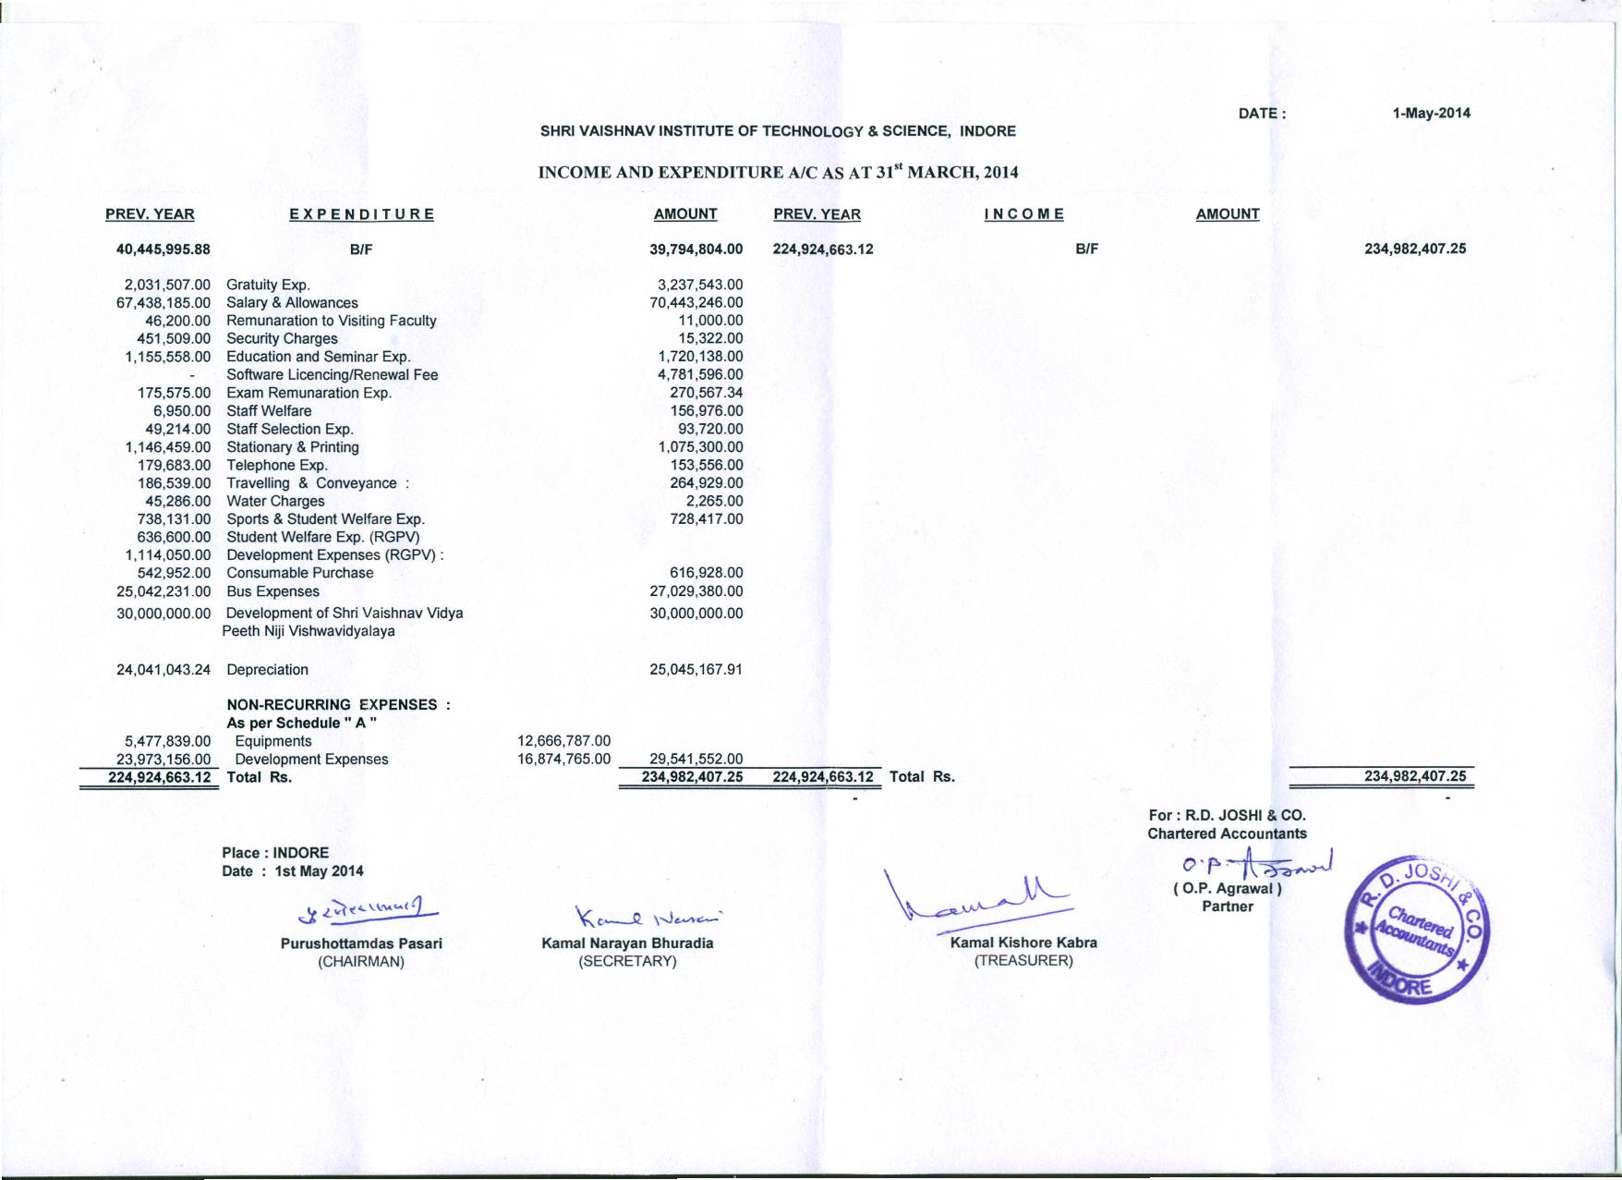

**Audited Balance Sheet as on 31 March 2014**

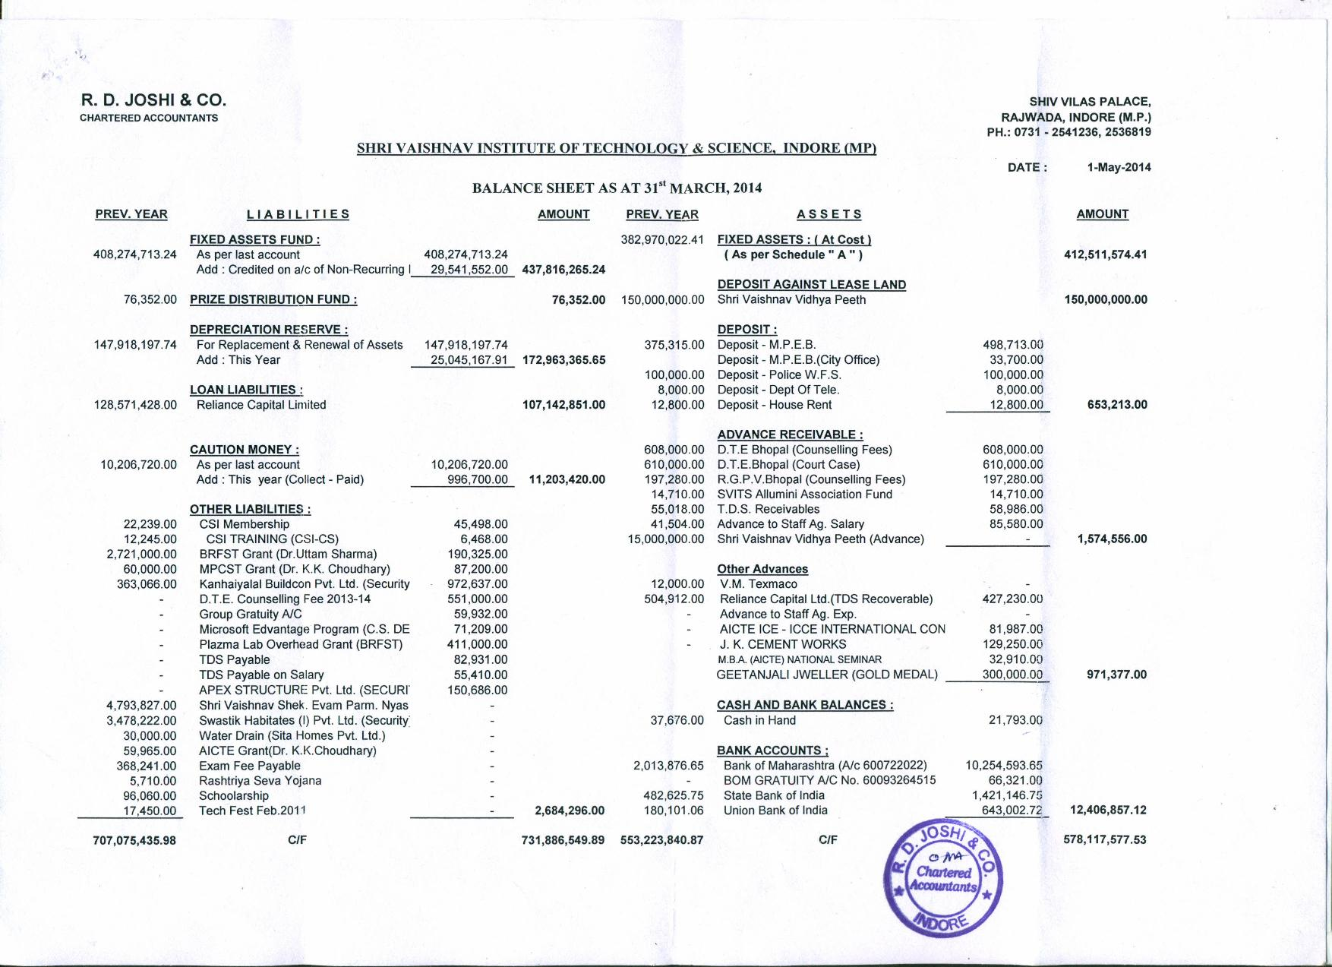

**Audited Balance Sheet as on 31 March 2014 (continued)**

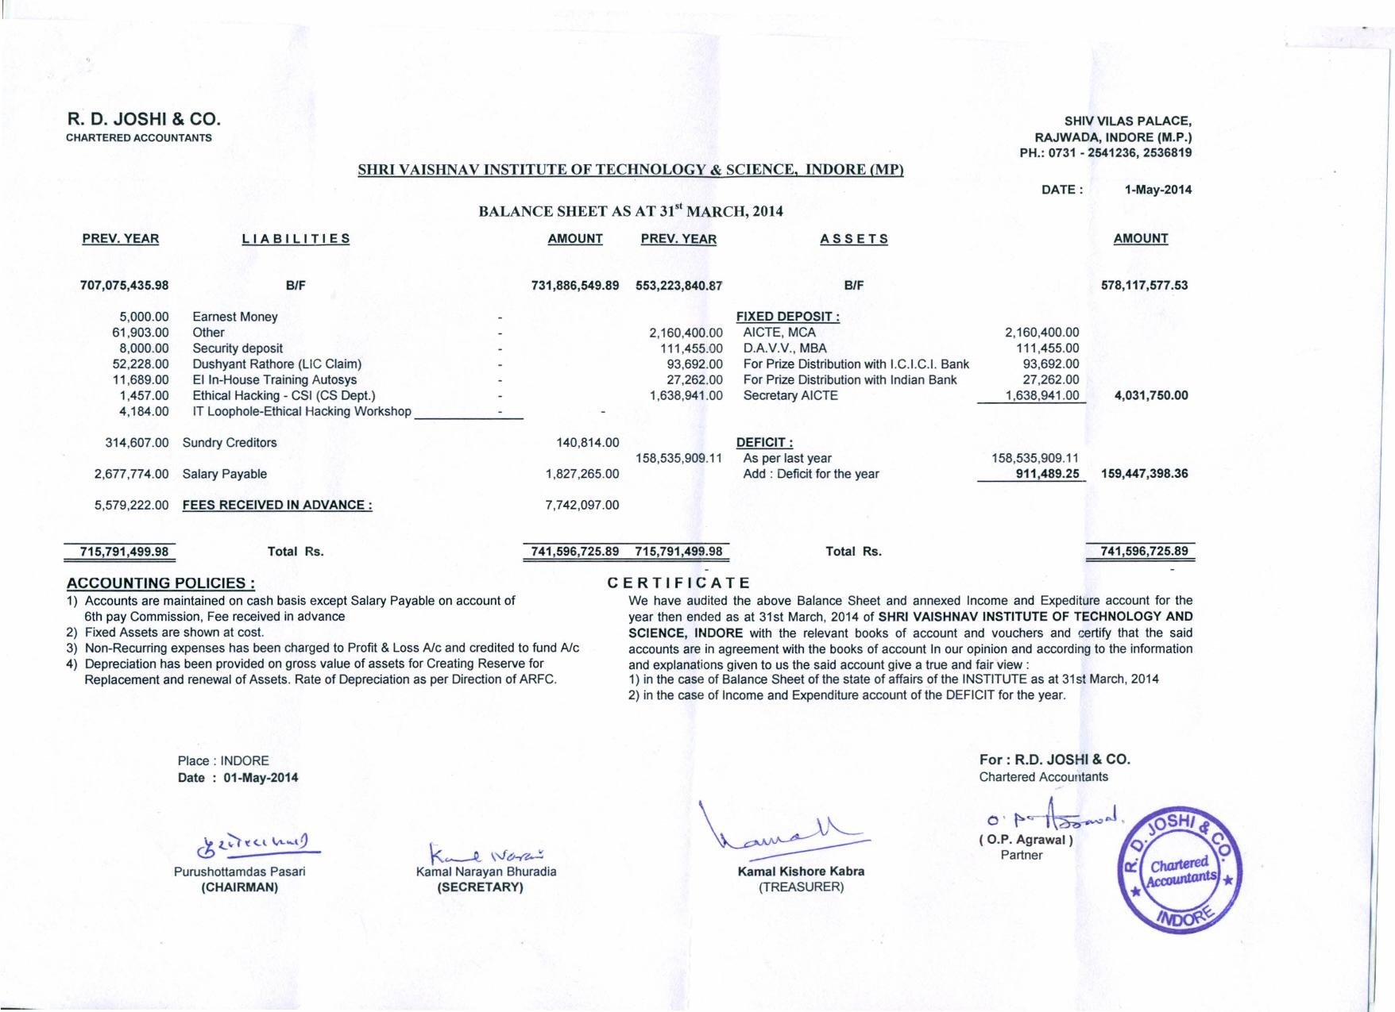

**Schedules to Audited Balance Sheet as on 31 March 2014**

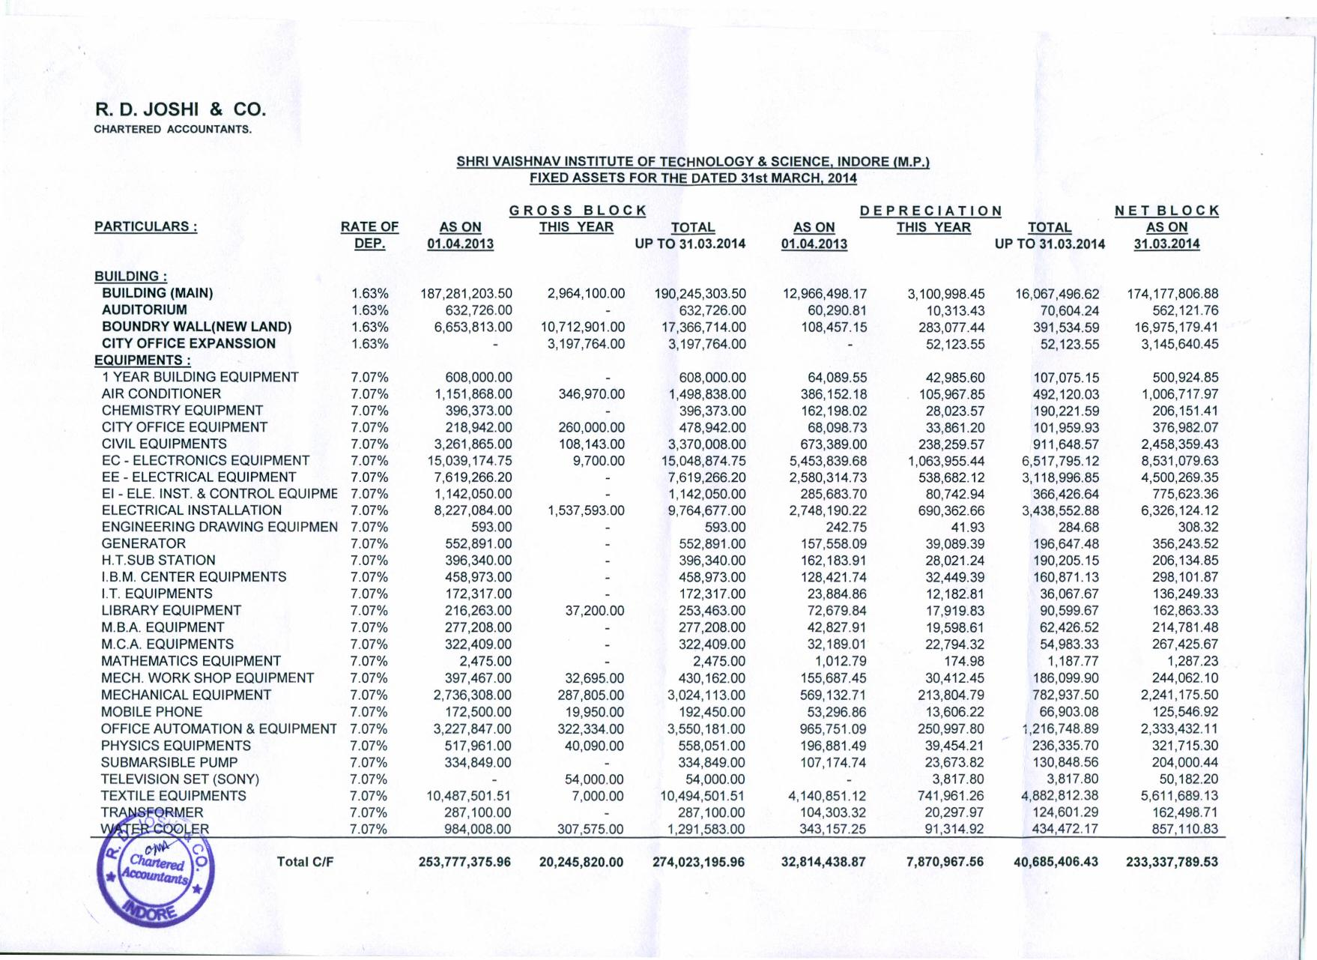

**Schedules to Audited Balance Sheet as on 31 March 2014 (continued)**

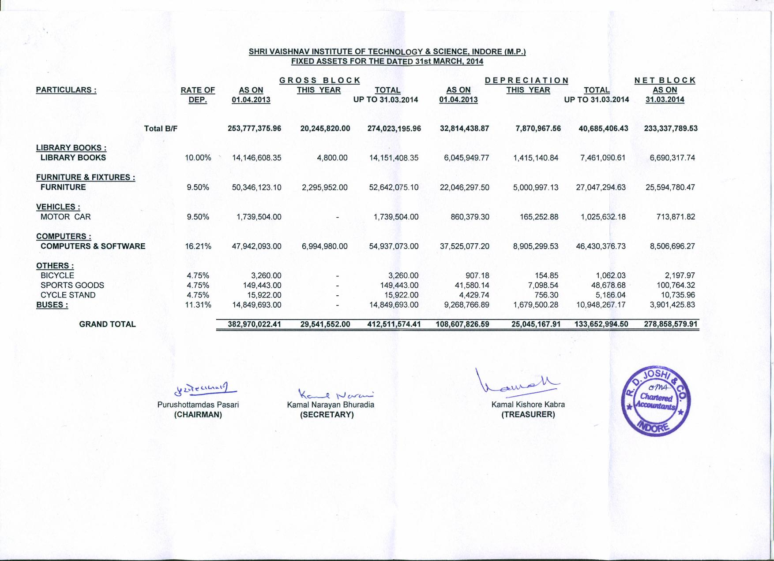

**Audited Income & Expenditure Statement for the year 2014-15**

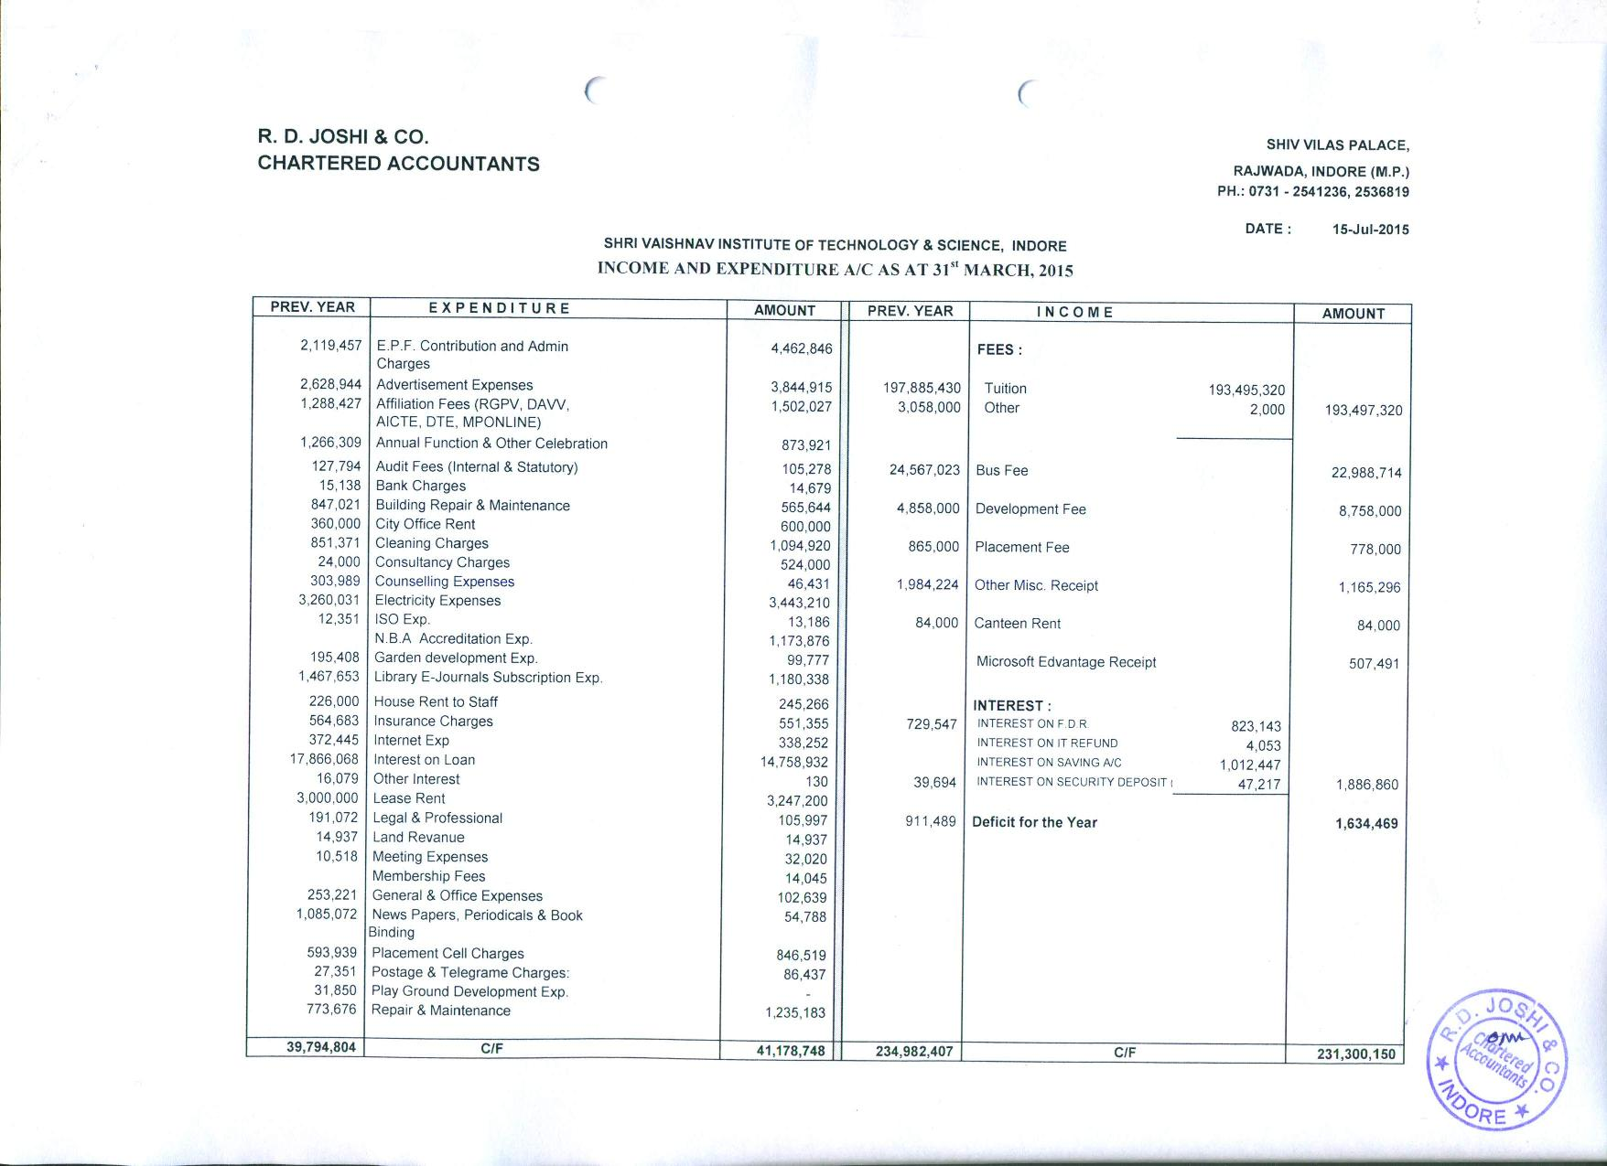

**Audited Income & Expenditure Statement for the year 2014-15 (continued)**

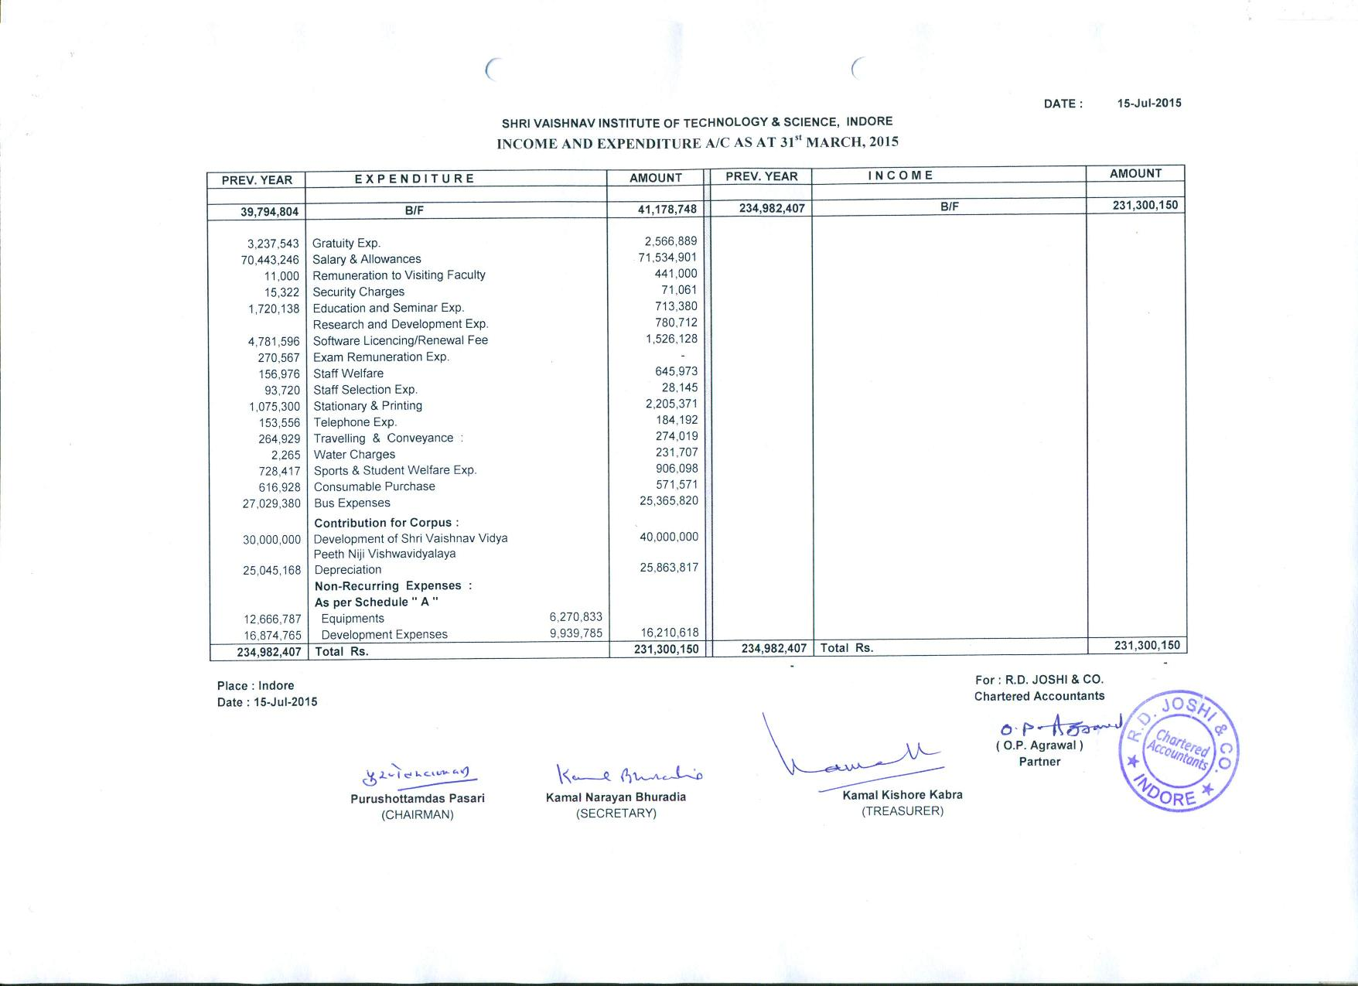

**Audited Balance Sheet as on 31 March 2015**

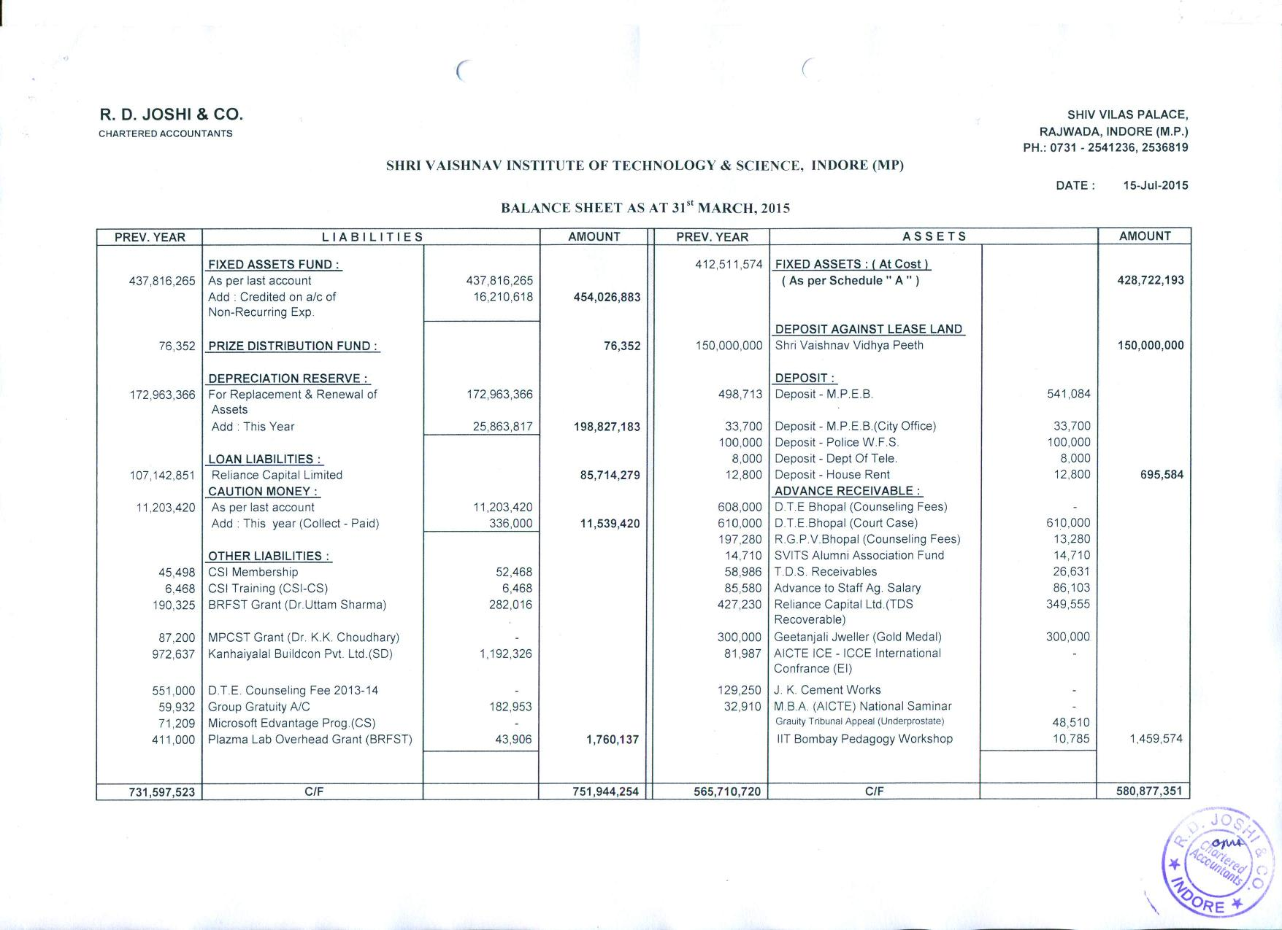

**Audited Balance Sheet as on 31 March 2015 (continued)**

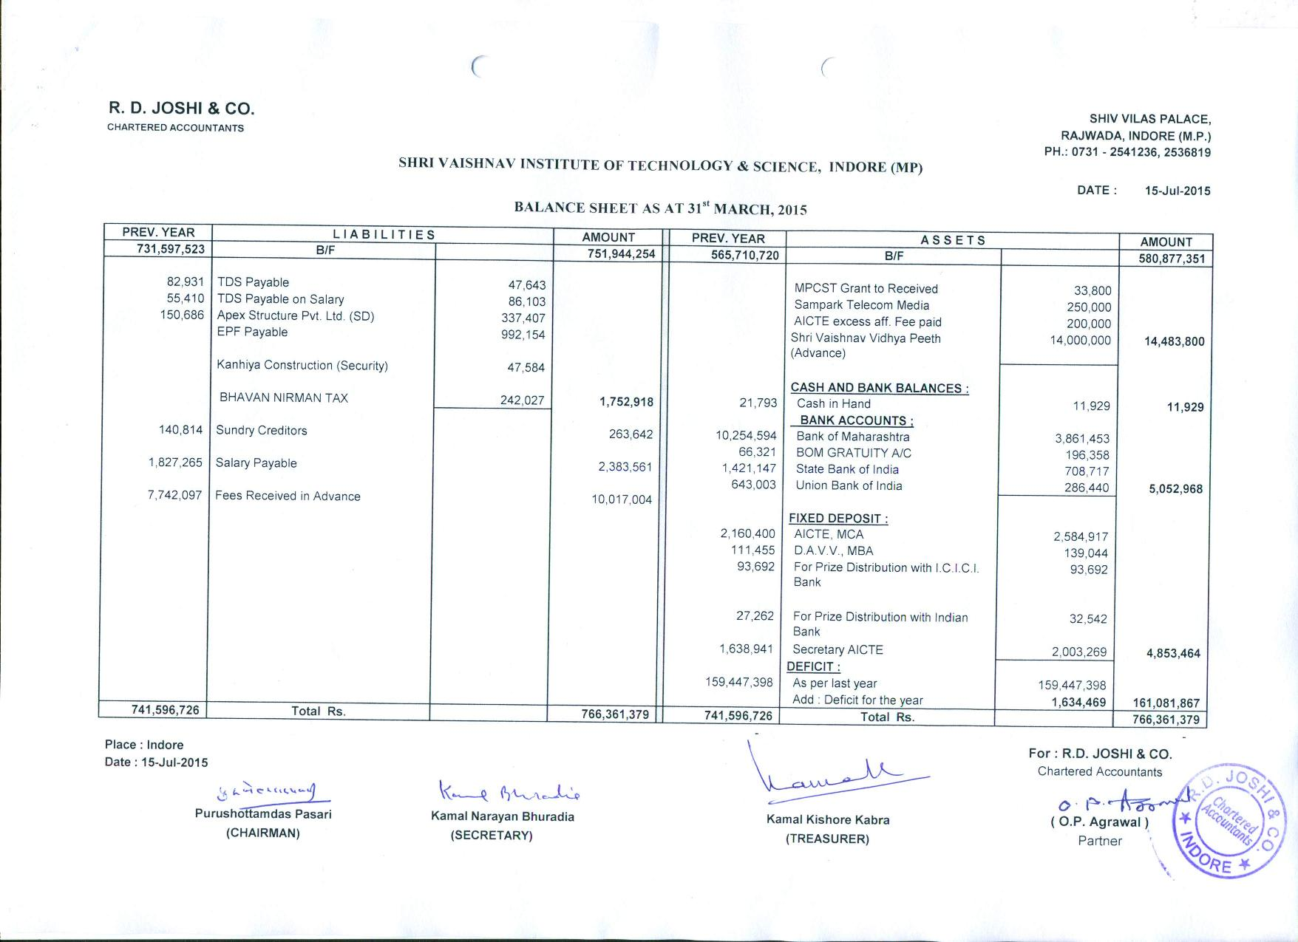

**Schedules to Audited Balance Sheet as on 31 March 2015**

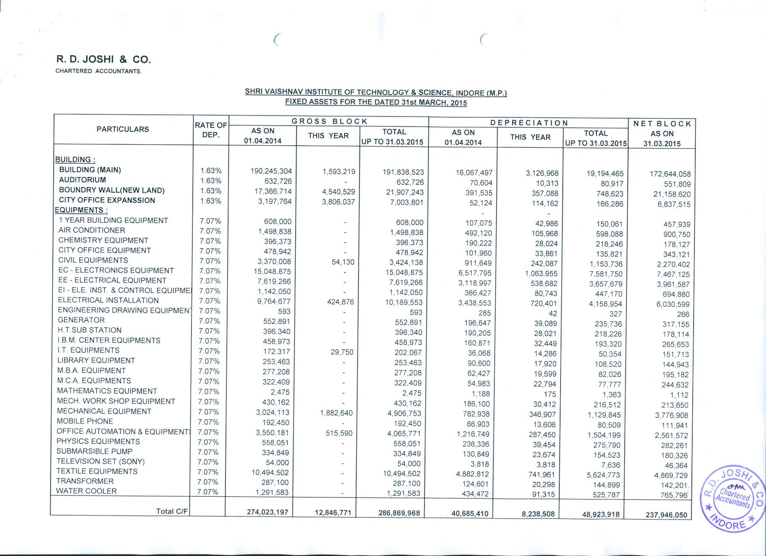

**Schedules to Audited Balance Sheet as on 31 March 2015 (continued)**

