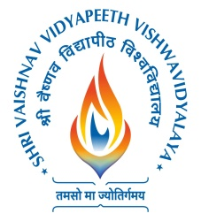 **Shri Vaishnav Vidyapeeth Vishwavidyalaya**

(Established under Madhya Pradesh Niji Vishwavidyalaya Adhiniyam)

Campus: Sanwer Road, Indore 453111

REQUIREMENT

--------------------------------------------------------------------------------------------------------------------------------------

Invites applications from the interested candidates for the following positions:

**Position**   **Eligibility**

• Librarian As per UGC Norms

• Assistant Librarian As per UGC Norms

• Library Assistant B.Lib./M.Lib. with minimum two years

experience in an Organization of repute.

Interested candidates may send applications in the prescribed format available on the University Website. Curriculum Vitae, photocopies of certificates and two passport size

photographs on **or before 8TH July 2022** to **The Chief Librarian, Shri Vaishnav Vidyapeeth Vishwavidyalaya, Shri Vaishnav Vidya Parisar,177, Jawahar Marg, South Rajmohalla, Indore- 452002**. It is mandatory to send application in hard copy.

\***E-mail: head-library@svvv.edu.in Website: www.svvv.edu.in**